C语言程序设计大作业

所选题目名称：纵版射击游戏设计

单 位：湘潭大学

班 级：计算机科学与技术二班

学 号：202205720832

姓 名：何新成

任课教师：谢勇

湘 潭 大 学

**2023**年**6**月

## 文档信息

|  |  |  |  |
| --- | --- | --- | --- |
| 源代码 | 可执行文件 | 自评成绩 | 答辩PPT |
| 有 | 有 | 优 | 有 |

## 学术诚信承诺书

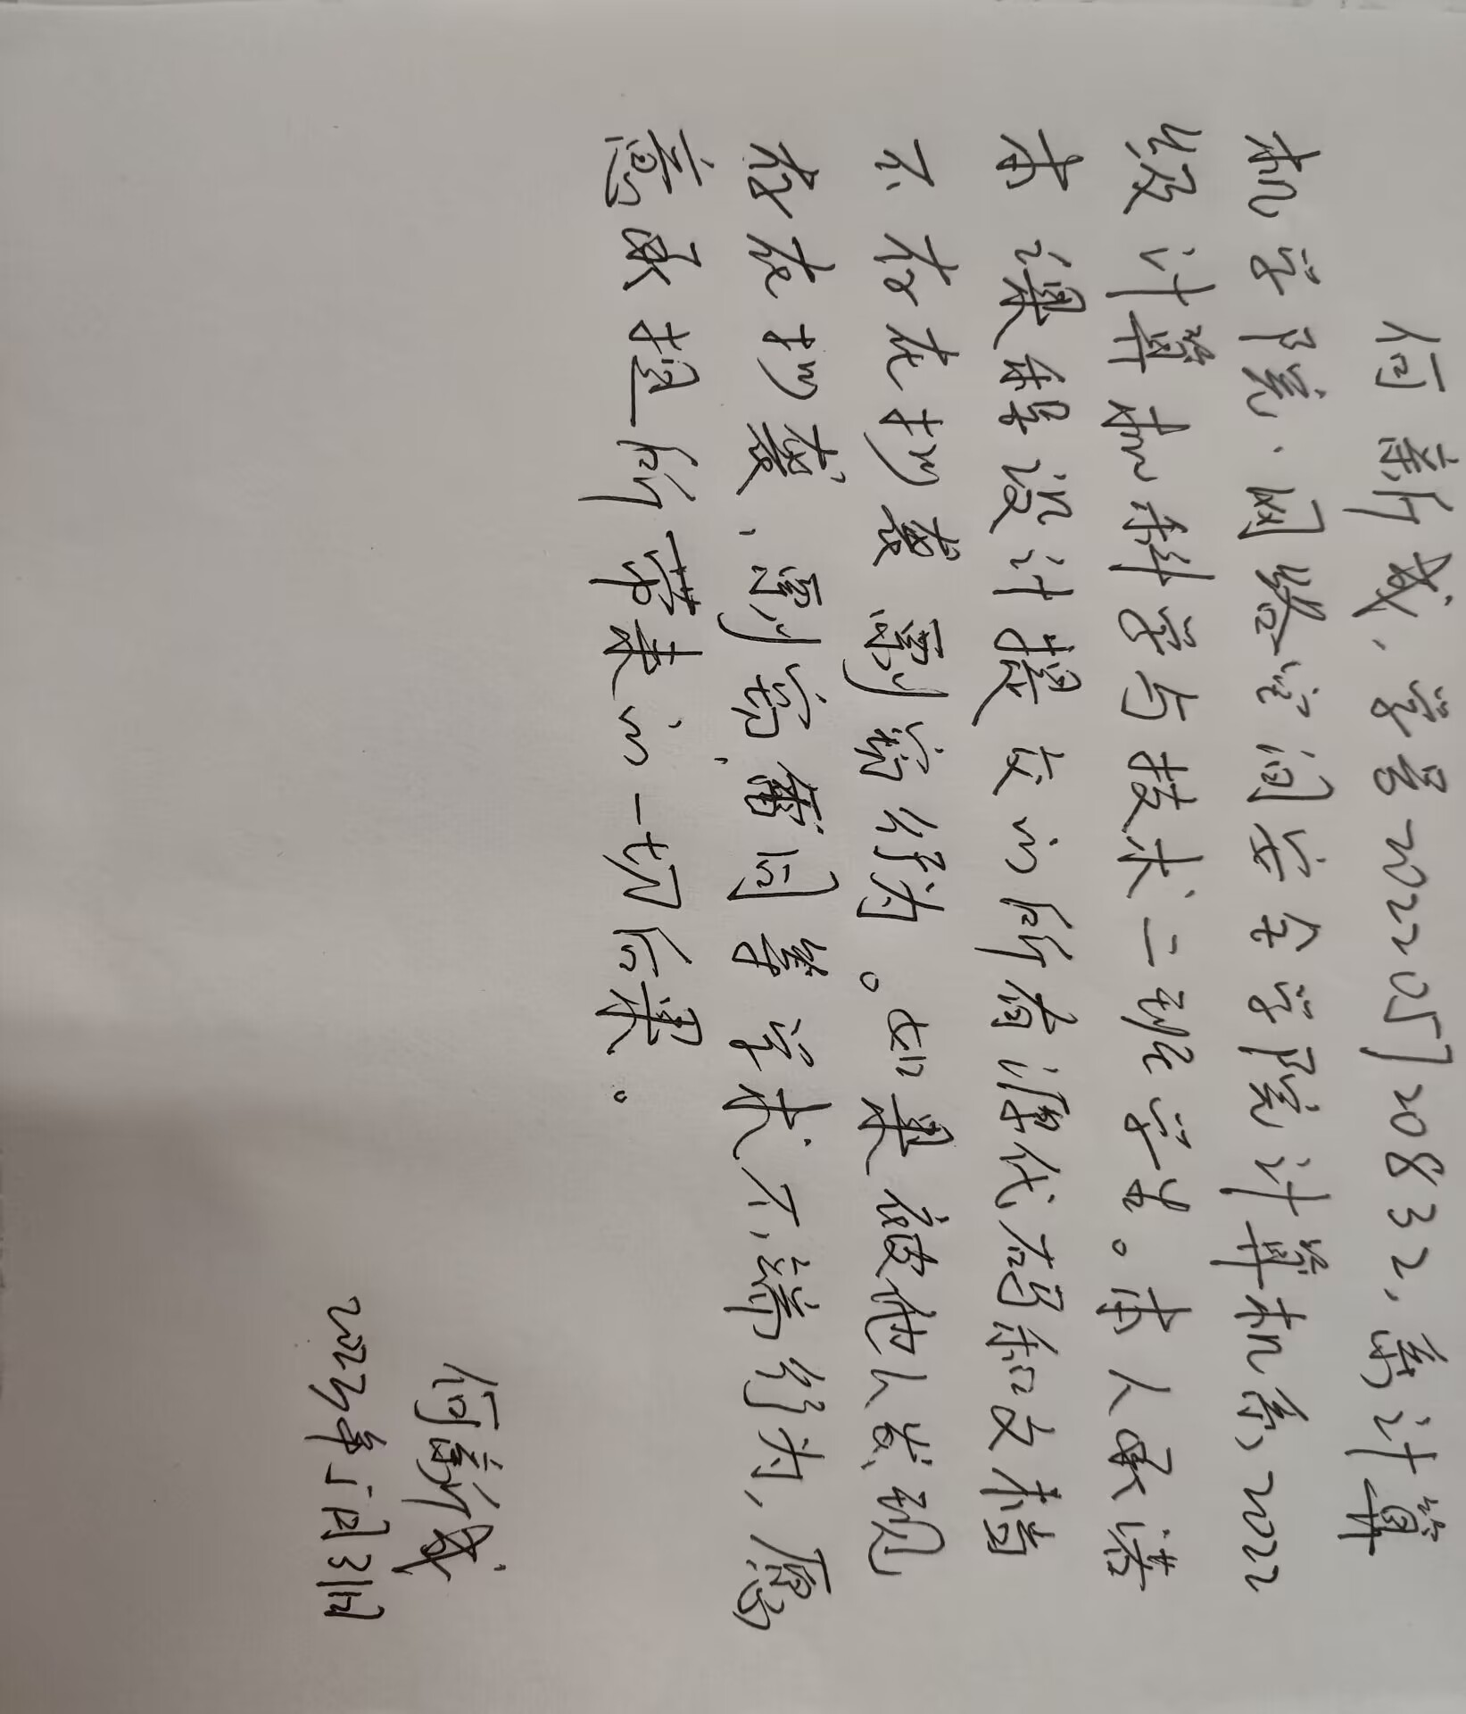题目概述

1. 概述

简要介绍本题目的内容，目标。

本题目内容为设计一种纵版射击游戏。目标为实现地图展示、方向控制，敌我子弹发射，碰撞检测等基本射击游戏元素，游戏存盘和读盘功能，成绩排行榜功能等基本功能，完成多种子弹、子弹威力升级系统，炸弹功能，游戏难易程度调节，游戏音乐与音效，BOSS战等选作功能。使游戏具有一定的可玩性，符合一般纵版射击游戏基本要求。

1. 所要完成的任务说明

|  |  |  |
| --- | --- | --- |
| 序号 | 功能分类 | 任务 |
| 1 | 必做 | 地图展示、方向控制，敌我子弹发射，碰撞检测等基本射击游戏元素 |
| 2 | 必做 | 游戏存盘和读盘功能 |
| 3 | 必做 | 成绩排行榜功能 |
| 4 | 选做 | 提供多种子弹、子弹威力升级系统 |
| 5 | 选做 | 提供炸弹功能 |
| 6 | 选做 | 游戏难易程度调节 |
| 7 | 选做 | 游戏音乐与音效 |
| 8 | 选做 | Boss战 |

1. 完成情况

|  |  |
| --- | --- |
| 功能序号 | 完成情况说明 |
| 1 | 完成 |
| 2 | 完成 |
| 3 | 完成 |
| 4 | 完成 |
| 5 | 完成 |
| 6 | 完成 |
| 7 | 完成 |
| 8 | 完成 |

1. 开发环境说明

简要介绍自己所用的开发环境，包括操作系统，开发工具等。

Visual Studio 2022,windows11,EasyX

## 程序分析与设计

1. 系统分析

要求1：创建了哪些函数，对函数分别进行详细说明。

说明要包含：

* 1. 函数原型；
  2. 函数的功能，如果有较为复杂的算法也需要说明；
  3. 各参数的意义；
  4. 函数的返回值类型

示例：

|  |  |
| --- | --- |
| 编号：001 | int TimerZero(int ms, int i, int id) |
| 函数功能 | 第一次调用能返回真值的定时器 |
| 参数说明 | ms: int型，定时的时间，单位毫秒  i: int型，事件的代号  id: int型，事件的代号 |
| 函数返回值 | int型，是否经过ms毫秒的时间 |

|  |  |
| --- | --- |
| 编号：002 | int TimerOne(int ms, int i, int id) |
| 函数功能 | 第二次或以上调用能返回真值的定时器 |
| 参数说明 | ms: int型，定时的时间，单位毫秒  i: int型，事件的代号  id: int型，事件的代号 |
| 函数返回值 | int型，是否经过ms毫秒的时间 |

|  |  |
| --- | --- |
| 编号：003 | int IsMouse(ExMessage* msg, int x, int y, int x1, int y1) |
| 函数功能 | 判断鼠标是否在指定矩形区域内 |
| 参数说明 | msg: 结构体指针型，指向鼠标信息的结构体  x: int型，指定矩形区域左上角的x坐标  y: int型，指定矩形区域左上角的y坐标  x1: int型，指定矩形区域右下角的x1坐标  y1: int型，指定矩形区域右下角的y1坐标 |
| 函数返回值 | int型，鼠标是否在指定矩形区域内 |

|  |  |
| --- | --- |
| 编号：004 | void LoadImage() |
| 函数功能 | 加载图片资源 |
| 参数说明 | 无 |
| 函数返回值 | 无 |

|  |  |
| --- | --- |
| 编号：005 | void DrawImage(IMAGE* image, int x, int y) |
| 函数功能 | 利用贝叶斯定理来进行点颜色的概率计算达到绘制透明图片的目的 |
| 参数说明 | image: 指针型，指向图片的指针  x: int型，要绘制图片的x坐标  y: int型，要绘制图片的y坐标 |
| 函数返回值 | 无 |

|  |  |
| --- | --- |
| 编号：006 | void PlayMusic(const char musicpath[100]) |
| 函数功能 | 播放音效 |
| 参数说明 | musicpath: char型，音效路径 |
| 函数返回值 | 无 |

|  |  |
| --- | --- |
| 编号：007 | void StartMenu(ExMessage* msg) |
| 函数功能 | 绘制开始菜单界面 |
| 参数说明 | msg: 结构体指针型，指向鼠标信息的结构体 |
| 函数返回值 | 无 |

|  |  |
| --- | --- |
| 编号：008 | void EnemyAttribute(int i) |
| 函数功能 | 初始化敌机属性及子弹规则 |
| 参数说明 | i: 结构体指针型，指向鼠标信息的结构体 |
| 函数返回值 | 无 |

|  |  |
| --- | --- |
| 编号：009 | void GameInit() |
| 函数功能 | 初始化游戏 |
| 参数说明 | 无 |
| 函数返回值 | 无 |

|  |  |
| --- | --- |
| 编号：010 | void CreatEnemyBullet(int i) |
| 函数功能 | 创建敌机子弹 |
| 参数说明 | i: 敌机代号 |
| 函数返回值 | 无 |

|  |  |
| --- | --- |
| 编号：011 | void CreatPlayerBullet() |
| 函数功能 | 创建玩家子弹 |
| 参数说明 | 无 |
| 函数返回值 | 无 |

|  |  |
| --- | --- |
| 编号：012 | void CreatEnemy() |
| 函数功能 | 创建敌机 |
| 参数说明 | 无 |
| 函数返回值 | 无 |

|  |  |
| --- | --- |
| 编号：013 | void PlayerBulletMove() |
| 函数功能 | 玩家子弹移动 |
| 参数说明 | 无 |
| 函数返回值 | 无 |

|  |  |
| --- | --- |
| 编号：014 | void EnemyBulletMove() |
| 函数功能 | 敌机子弹移动 |
| 参数说明 | 无 |
| 函数返回值 | 无 |

|  |  |
| --- | --- |
| 编号：015 | void PlayerMove(int speed, ExMessage* msg) |
| 函数功能 | 玩家移动 |
| 参数说明 | speed: 玩家移动速度  msg: 结构体指针型，指向鼠标信息的结构体 |
| 函数返回值 | 无 |

|  |  |
| --- | --- |
| 编号：016 | void EnemyMove() |
| 函数功能 | 敌机移动 |
| 参数说明 | 无 |
| 函数返回值 | 无 |

|  |  |
| --- | --- |
| 编号：017 | void SupplyDropMove() |
| 函数功能 | 掉落道具移动 |
| 参数说明 | 无 |
| 函数返回值 | 无 |

|  |  |
| --- | --- |
| 编号：018 | void BulletLevel() |
| 函数功能 | 玩家子弹升级 |
| 参数说明 | 无 |
| 函数返回值 | 无 |

|  |  |
| --- | --- |
| 编号：019 | void Hit() |
| 函数功能 | 所有碰撞判定及结果 |
| 参数说明 | 无 |
| 函数返回值 | 无 |

|  |  |
| --- | --- |
| 编号：020 | void ChosePlane(ExMessage* msg) |
| 函数功能 | 绘制飞机及难度选择界面 |
| 参数说明 | msg: 结构体指针型，指向鼠标信息的结构体 |
| 函数返回值 | 无 |

|  |  |
| --- | --- |
| 编号：021 | void Load(const char* filename) |
| 函数功能 | 读档 |
| 参数说明 | filename:指针型，指向文件名字符串 |
| 函数返回值 | 无 |

|  |  |
| --- | --- |
| 编号：022 | void Save(const char* filename) |
| 函数功能 | 存档 |
| 参数说明 | filename:指针型，指向文件名字符串 |
| 函数返回值 | 无 |

|  |  |
| --- | --- |
| 编号：023 | void LoadList(const char* filename) |
| 函数功能 | 读取排行榜 |
| 参数说明 | filename:指针型，指向文件名字符串 |
| 函数返回值 | 无 |

|  |  |
| --- | --- |
| 编号：024 | void SaveList(const char* filename) |
| 函数功能 | 保存排行榜 |
| 参数说明 | filename:指针型，指向文件名字符串 |
| 函数返回值 | 无 |

|  |  |
| --- | --- |
| 编号：025 | void SaveScore() |
| 函数功能 | 保存成绩和玩家昵称 |
| 参数说明 | 无 |
| 函数返回值 | 无 |

|  |  |
| --- | --- |
| 编号：026 | void CreatBoss() |
| 函数功能 | 创建并初始化BOSS及其子弹规则 |
| 参数说明 | 无 |
| 函数返回值 | 无 |

|  |  |
| --- | --- |
| 编号：027 | void CreatBossBulletOne() |
| 函数功能 | 创建BOSS子弹一 |
| 参数说明 | 无 |
| 函数返回值 | 无 |

|  |  |
| --- | --- |
| 编号：028 | void CreatBossBulletTwo() |
| 函数功能 | 创建BOSS子弹二 |
| 参数说明 | 无 |
| 函数返回值 | 无 |

|  |  |
| --- | --- |
| 编号：029 | void CreatBossBulletThree() |
| 函数功能 | 创建BOSS子弹三 |
| 参数说明 | 无 |
| 函数返回值 | 无 |

|  |  |
| --- | --- |
| 编号：030 | void CreatBossBomb() |
| 函数功能 | 创建BOSS导弹 |
| 参数说明 | 无 |
| 函数返回值 | 无 |

|  |  |
| --- | --- |
| 编号：031 | void BossBulletMove() |
| 函数功能 | BOSS子弹及导弹移动 |
| 参数说明 | 无 |
| 函数返回值 | 无 |

|  |  |
| --- | --- |
| 编号：032 | void BossComing() |
| 函数功能 | BOSS行动 |
| 参数说明 | 无 |
| 函数返回值 | 无 |

|  |  |
| --- | --- |
| 编号：033 | void GameOver(ExMessage* msg) |
| 函数功能 | 绘制游戏结束界面 |
| 参数说明 | filename:指针型，指向文件名字符串 |
| 函数返回值 | 无 |

|  |  |
| --- | --- |
| 编号：034 | void GameDraw() |
| 函数功能 | 绘制开始菜单界面 |
| 参数说明 | 游戏总绘制 |
| 函数返回值 | 无 |

|  |  |
| --- | --- |
| 编号：035 | void GameStart(ExMessage* msg) |
| 函数功能 | 游戏开始调用相关函数 |
| 参数说明 | filename:指针型，指向文件名字符串 |
| 函数返回值 | 无 |

|  |  |
| --- | --- |
| 编号：036 | void GameStop(ExMessage* msg) |
| 函数功能 | 绘制游戏暂停界面 |
| 参数说明 | filename:指针型，指向文件名字符串 |
| 函数返回值 | 无 |

|  |  |
| --- | --- |
| 编号：037 | void Battle(ExMessage* msg) |
| 函数功能 | 战斗界面活动控制 |
| 参数说明 | filename:指针型，指向文件名字符串 |
| 函数返回值 | 无 |

|  |  |
| --- | --- |
| 编号：038 | void GameContinue() |
| 函数功能 | 继续游戏初始化数据 |
| 参数说明 | 无 |
| 函数返回值 | 无 |

|  |  |
| --- | --- |
| 编号：039 | void ScoreList() |
| 函数功能 | 绘制排行榜界面 |
| 参数说明 | 无 |
| 函数返回值 | 无 |

|  |  |
| --- | --- |
| 编号：040 | void About(const char* filename) |
| 函数功能 | 绘制关于界面 |
| 参数说明 | filename:指针型，指向文件名字符串 |
| 函数返回值 | 无 |

|  |  |
| --- | --- |
| 编号：041 | int main() |
| 函数功能 | 主函数，初始化及控制游戏界面 |
| 参数说明 | 无 |
| 函数返回值 | 无 |

要求2：函数之间的调用关系图

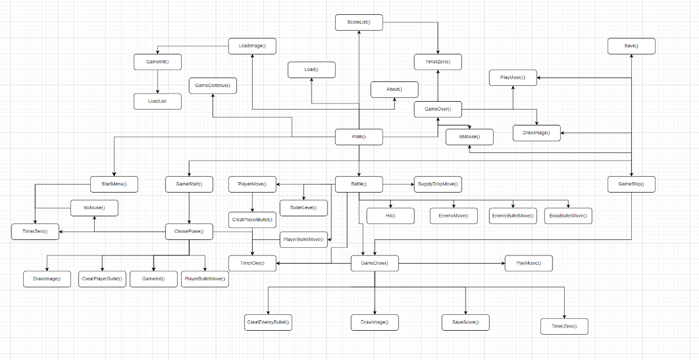

1. 函数设计

要求：

在每个3级标题下，对创建的每个函数分别画出流程图（推荐使用visio或者draw.io等专业绘图工具），贴出对应代码和注释，无流程图、无代码注释、注释与流程图对应不上不得分。

(1)

int TimerZero(int ms, int i, int id) //定时器，i=0为总，2为激光子弹判断，id=0和1为玩家短暂无敌,2为防止鼠标连点

{

static DWORD t[2][50];

if (clock() - t[i][id] > ms)

{

t[i][id] = clock();

return 1;

}

return 0;

}

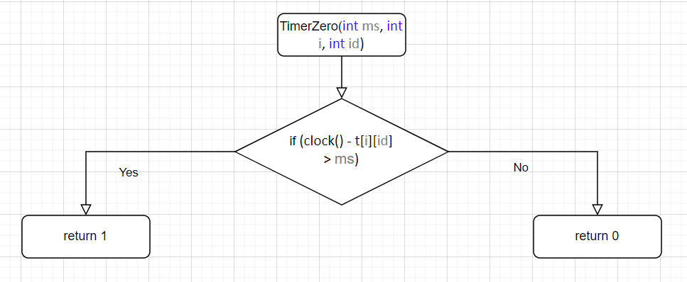

(2)

int TimerOne(int ms, int i, int id) //定时器,i=0为总,1为敌机子弹,2为死亡动画,3为护盾持续时间,4为狂暴持续时间;id=0为创建敌机，1为玩家子弹发射，2为保存游戏，3为选择按下间隔,4为演示子弹发射,5为满级之后创建敌机速度 6和7-9为BOSS子弹,10为BOSS导弹发射,11为演示子弹升级

{

static DWORD t[5][50];

static int initialized[5][50];

if (!initialized[i][id]) //判断是否为第一次执行

{

t[i][id] = clock();

initialized[i][id] = 1;

}

if (clock() - t[i][id] > ms)

{

t[i][id] = clock();

return 1;

}

return 0;

}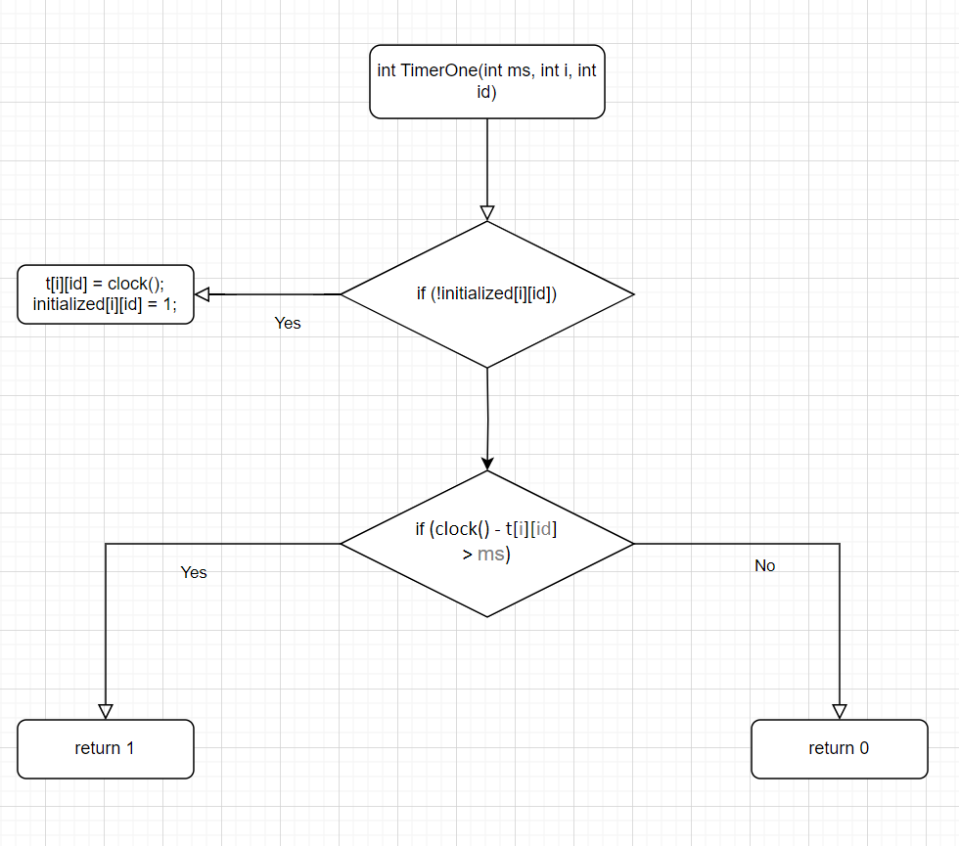

(3)

int IsMouse(ExMessage* msg, int x, int y, int x1, int y1) //判断鼠标位置是否在某区域内

{

if (msg->x > x && msg->x < x1 && msg->y > y && msg->y < y1)

return 1;

return 0;

}

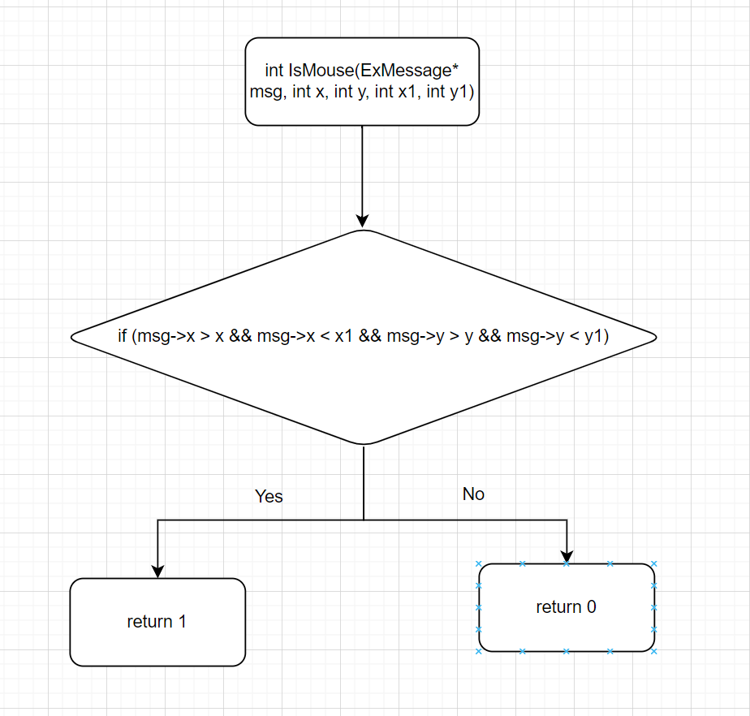

(4)

void LoadImage()

{

char path[100];

for (int i = 0; i < 3; i++) //使用循环优化代码

{

sprintf_s(path, "./res/images/map%d.png", i + 1);

loadimage(img_map + i, path);

sprintf_s(path, "./res/images/boss%d.png", i + 1);

loadimage(img_boss + i, path);

sprintf_s(path, "./res/images/enemybullet%d.png", i + 1);

loadimage(img_enemybullet + i, path);

loadimage(&img_bossbullet[i], "./res/images/bossbullet.png");

for (int j = 0; j < 2; j++)

{

sprintf_s(path, "./res/images/difficulty%d%d.png", i + 1, j + 1);

loadimage(img_difficulty[i] + j, path);

}

for (int j = 0; j < 3; j++)

{

sprintf_s(path, "./res/images/boss%d_die%d.png", i + 1, j + 1);

loadimage(img_bossdie[i] + j, path);

}

}

for (int i = 0; i < 4; i++)

{

sprintf_s(path, "./res/images/supply%d_drop.png", i + 1);

loadimage(img_supplydrop + i, path);

sprintf_s(path, "./res/images/choseplane%d.png", i + 1);

loadimage(img_choseplane + i, path);

sprintf_s(path, "./res/images/plane%d.png", i + 1);

loadimage(img_plane + i, path);

for (int j = 0; j < 3; j++)

{

sprintf_s(path, "./res/images/playerbullet%d%d.png", i + 1, j + 1);

loadimage(img_playerbullet[i] + j, path);

}

}

for (int i = 0; i < 5; i++)

{

sprintf_s(path, "./res/images/menu%d.png", i + 1);

loadimage(img_menu + i, path);

sprintf_s(path, "./res/images/enemy%d.png", i + 1);

loadimage(img_enemy + i, path);

sprintf_s(path, "./res/images/enemy%d_die.png", i + 1);

loadimage(img_enemydie + i, path);

}

loadimage(&img_scorelist, "./res/images/scorelist.png");

loadimage(&img_state, "./res/images/state.png");

loadimage(&img_choseplanebackground, "./res/images/choseplanebackground.png");

loadimage(&img_gameover, "./res/images/gameover.png");

loadimage(&img_playerdie, "./res/images/player_die.png");

loadimage(&img_bossbomb, "./res/images/bossbomb.png");

loadimage(&img_supply[0], "./res/images/supply1.png");

loadimage(&img_supply[3], "./res/images/supply4.png");

loadimage(&img_bombbomb, "./res/images/bombbomb.png");

loadimage(&img_invincibility, "./res/images/invincibility.png");

loadimage(&img_stop, "./res/images/stop.png");

loadimage(&img_about, "./res/images/about.png");

loadimage(&img_returnmenu[0], "./res/images/returnmenu1.png");

loadimage(&img_returnmenu[1], "./res/images/returnmenu2.png");

loadimage(&img_savegame[0], "./res/images/savegame1.png");

loadimage(&img_savegame[1], "./res/images/savegame2.png");

loadimage(&img_continuegame[0], "./res/images/continuegame1.png");

loadimage(&img_continuegame[1], "./res/images/continuegame2.png");

loadimage(&img_return[0], "./res/images/return1.png");

loadimage(&img_return[1], "./res/images/return2.png");

loadimage(&img_tryagain[0], "./res/images/tryagain1.png");

loadimage(&img_tryagain[1], "./res/images/tryagain2.png");

loadimage(&img_battle[0], "./res/images/battle1.png");

loadimage(&img_battle[1], "./res/images/battle2.png");

}

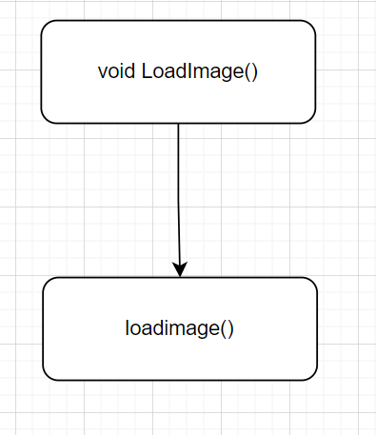

(5)

void DrawImage(IMAGE* image, int x, int y)

{

double AA = 1;

DWORD* dst = GetImageBuffer(); // GetImageBuffer() 函数，用于获取绘图设备的显存指针， EasyX 自带

DWORD* draw = GetImageBuffer();

DWORD* src = GetImageBuffer(image); // 获取 picture 的显存指针

int imageWidth = image->getwidth(); // 获取图片宽度

int imageHeight = image->getheight(); // 获取图片高度

int dstX = 0; // 在 绘图区域 显存里像素的角标

int srcX = 0; // 在 image 显存里像素的角标

// 实现透明贴图 公式： Cp=αp*FP+(1-αp)*BP ， 贝叶斯定理来进行点颜色的概率计算

for (int iy = 0; iy < imageHeight; iy++)

{

for (int ix = 0; ix < imageWidth; ix++)

{

// 防止越界

if (ix + x >= 0 && ix + x < WINDOWWIDTH && iy + y >= 0 && iy + y < WINDOWHEIGHT)

{

// 获取像素角标

int srcX = ix + iy * imageWidth;

dstX = (ix + x) + (iy + y) * WINDOWWIDTH;

int sa = ((src[srcX] & 0xff000000) >> 24) * AA; // 0xAArrggbb; AA 是透明度

int sr = ((src[srcX] & 0xff0000) >> 16); // 获取 RGB 里的 R

int sg = ((src[srcX] & 0xff00) >> 8); // 获取 RGB 里的G

int sb = src[srcX] & 0xff; // 获取 RGB 里的B

// 设置对应的绘图区域像素信息

int dr = ((dst[dstX] & 0xff0000) >> 16);

int dg = ((dst[dstX] & 0xff00) >> 8);

int db = dst[dstX] & 0xff;

draw[dstX] = ((sr * sa / 255 + dr * (255 - sa) / 255) << 16) //公式： Cp=αp*FP+(1-αp)*BP ； αp=sa/255 , FP=sr , BP=dr

| ((sg * sa / 255 + dg * (255 - sa) / 255) << 8) //αp=sa/255 , FP=sg , BP=dg

| (sb * sa / 255 + db * (255 - sa) / 255); //αp=sa/255 , FP=sb , BP=db

}

}

}

}

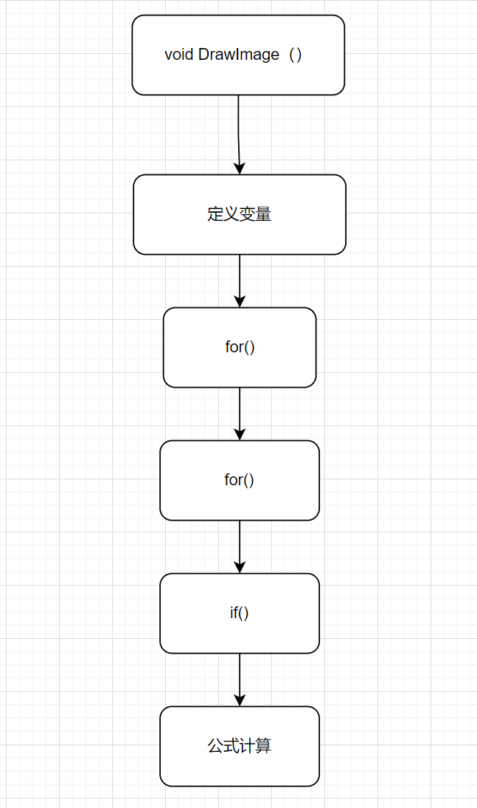

(6)

void PlayMusic(const char musicpath[100]) //加const使参数为只读，扩大了参数接受范围

{

PlaySound(musicpath, NULL, SND_ASYNC | SND_FILENAME | SND_NOSTOP); //异步、指定文件名、不打断原来音乐播放

}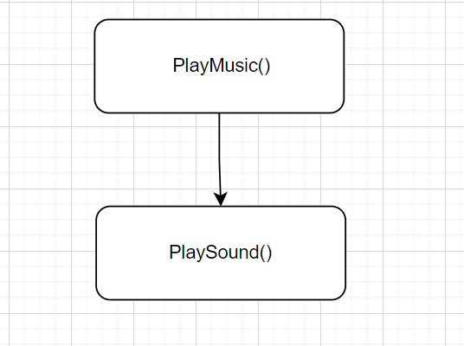

(7)

void StartMenu(ExMessage* msg) //开始菜单

{

mciSendString("open ./res/media/menu.wav type MPEGVideo", NULL, NULL, NULL);

mciSendString("play ./res/media/menu.wav repeat", NULL, NULL, NULL);

if (IsMouse(msg, 160, 555, 350, 600))

{

putimage(0, 0, &img_menu[1]);

if (msg->message == WM_LBUTTONDOWN && TimerZero(300, 0, 2)) //开始游戏

{

thread musicThread(PlayMusic, "./res/media/click.wav");

musicThread.detach();

SCENE = GAMESTART;

}

}

else if (IsMouse(msg, 155, 640, 350, 686))

{

putimage(0, 0, &img_menu[2]);

if (msg->message == WM_LBUTTONDOWN && TimerZero(300, 0, 2)) //继续游戏

{

thread musicThread(PlayMusic, "./res/media/click.wav");

musicThread.detach();

SCENE = GAMECONTINUE;

}

}

else if (IsMouse(msg, 178, 718, 320, 768)) //排行榜

{

putimage(0, 0, &img_menu[3]);

if (msg->message == WM_LBUTTONDOWN && TimerZero(300, 0, 2))

{

thread musicThread(PlayMusic, "./res/media/click.wav");

musicThread.detach();

SCENE = SCORELIST;

}

}

else if (IsMouse(msg, 204, 807, 298, 845)) //关于

{

putimage(0, 0, &img_menu[4]);

if (msg->message == WM_LBUTTONDOWN && TimerZero(300, 0, 2))

{

thread musicThread(PlayMusic, "./res/media/click.wav");

musicThread.detach();

SCENE = ABOUT;

}

}

else

{

putimage(0, 0, &img_menu[0]);

}

}

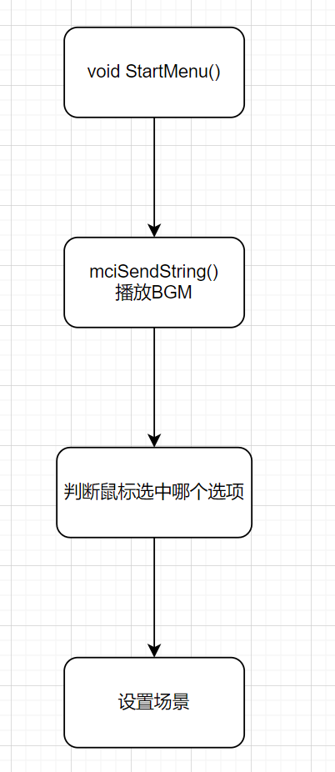

(8)

void EnemyAttribute(int i) //初始化敌人属性

{

if (rand() % 100 >= 0 && rand() % 100 <= 10) //类型二的飞机

{

enemy[i].type = 2;

}

else if (rand() % 100 >= 0 && rand() % 100 <= 20) //类型一的飞机

{

enemy[i].type = 1;

}

else //类型零的飞机

{

enemy[i].type = 0;

}

if (ifdifficult >= 2)

{

if (rand() % 100 >= 0 && rand() % 100 <= 3 || (gamer.score % 100 == 0 && gamer.score != 0 && rand() % 2)) //类型三的飞机

{

enemy[i].type = 3;

}

if (gamer.score > 1000) //到达一千分加大刷新高级敌机概率

{

if (rand() % 100 >= 0 && rand() % 100 <= 6 || (gamer.score % 100 == 0 && gamer.score != 0 && rand() % 2)) //类型三的飞机

{

enemy[i].type = 3;

}

}

else if (ifdifficult == 3)

{

if (rand() % 100 >= 0 && rand() % 100 <= 2 || (gamer.score % 200 == 0 && gamer.score != 0 && rand() % 2)) //类型四的飞机

{

enemy[i].type = 4;

}

if (gamer.score > 1000)

{

if (rand() % 100 >= 0 && rand() % 100 <= 4 || (gamer.score % 200 == 0 && gamer.score != 0 && rand() % 2)) //类型四的飞机

{

enemy[i].type = 4;

}

}

}

}

switch (enemy[i].type)

{

case 0:

enemy[i].hp = 1;

enemy[i].width = 65;

enemy[i].height = 50;

enemy[i].speed = 2.5;

enemy[i].x = rand() % (WINDOWWIDTH - enemy[i].width);

enemy[i].y = -enemy[i].height;

enemy[i].bulletnum = 0;

break;

case 1:

enemy[i].hp = 6;

if (gamer.score > 1000)

enemy[i].hp = 10;

enemy[i].width = 102;

enemy[i].height = 100;

enemy[i].speed = 1;

enemy[i].x = rand() % (WINDOWWIDTH - enemy[i].width);

enemy[i].y = -enemy[i].height;

enemy[i].bulletnum = 0;

break;

case 2:

enemy[i].hp = 5;

if (gamer.score > 1000)

enemy[i].hp = 8;

enemy[i].width = 126;

enemy[i].height = 116;

enemy[i].speed = 1.5;

enemy[i].x = rand() % (WINDOWWIDTH - enemy[i].width);

enemy[i].y = -enemy[i].height;

enemy[i].bulletspeed = 3;

enemy[i].bulletnum = 1;

enemy[i].bullettime = 3000;

for (int j = 0; j < enemy[i].bulletnum; j++)

{

enemybullet[i][j].bulletspeed = 2;

if (gamer.score > 1000)

enemybullet[i][j].bulletspeed = 3;

}

break;

case 3:

enemy[i].hp = 30;

if (gamer.score > 1000)

enemy[i].hp = 50;

enemy[i].width = 150;

enemy[i].height = 110;

enemy[i].speed = 1;

enemy[i].x = rand() % (WINDOWWIDTH - enemy[i].width);

enemy[i].y = -enemy[i].height;

enemy[i].bulletspeed = 3;

enemy[i].bulletnum = 20;

enemy[i].bullettime = 3000;

for (int j = 0; j < enemy[i].bulletnum; j++)

{

enemybullet[i][j].bulletspeed = 3;

}

break;

case 4:

enemy[i].hp = 50;

if (gamer.score > 1000)

enemy[i].hp = 70;

enemy[i].width = 150;

enemy[i].height = 200;

enemy[i].speed = 1;

if (rand() % 2)

enemy[i].x = -enemy[i].width;

else

enemy[i].x = WINDOWWIDTH;

enemy[i].y = 100;

enemy[i].bulletspeed = 1;

enemy[i].bulletnum = 18;

enemy[i].bullettime = 100;

enemybullet[i][0].bulletspeed = 1;

for (int j = 0; j < enemy[i].bulletnum; j++)

{

for (int k1 = 0; k1 < 4; k1++, j++)

enemybullet[i][j].bulletspeed = enemybullet[i][j - 1].bulletspeed + 1;

for (int k2 = 0; k2 < 20; k2++, j++)

enemybullet[i][j].bulletspeed = enemybullet[i][j - 1].bulletspeed - 0.8;

for (int k3 = 0; k3 < 3; k3++, j++)

enemybullet[i][j].bulletspeed = enemybullet[i][j - 1].bulletspeed + 1;

if (j % 18 == 0)

{

enemybullet[i][j].bulletspeed = 1;

}

}

break;

}

}

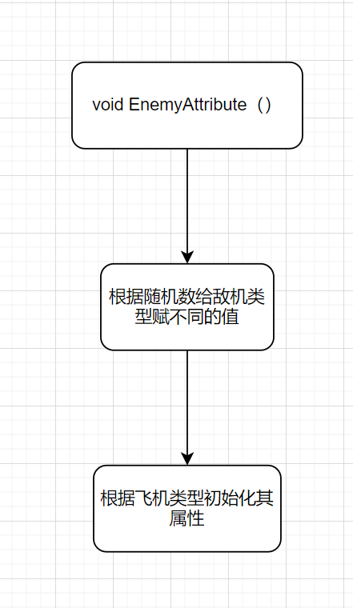

(9)

void GameInit()

{

gamer.score = 0;

hitboss.score = 999;

map[ifdifficult - 1].width = img_map[ifdifficult - 1].getwidth();

map[ifdifficult - 1].height = img_map[ifdifficult - 1].getheight();

map[ifdifficult - 1].x = 0;

map[ifdifficult - 1].y = -(map[ifdifficult - 1].height - WINDOWHEIGHT);

player.x = WINDOWWIDTH / 2 - player.width / 2;

player.y = WINDOWHEIGHT - player.height;

player.live = 1;

player.bulletlevel = 0;

switch (player.type)

{

case 0:

player.hp = 10;

player.bulletspeed = 2;

player.bullettime = 1000;

player.firepower = 1;

break;

case 1:

player.hp = 5;

player.bulletspeed = 4;

player.bullettime = 600;

player.firepower = 1;

break;

case 2:

player.hp = 10;

player.bulletspeed = 2;

player.bullettime = 1500;

player.firepower = 2;

break;

case 3:

player.hp = 5;

player.bullettime = 200;

player.firepower = 1;

break;

}

for (int i = 0; i < SUPPLY_NUM; i++)

{

supplydrop[i].width = img_supplydrop[i].getwidth();

supplydrop[i].height = img_supplydrop[i].getheight();

supplydrop[i].live = 0;

supplydrop[i].bulletspeed = 1; //x轴速度

supplydrop[i].speed = 1; //y轴速度

supply[i].live = 0;

}

supply[0].x = 0; //使炸弹显示在状态栏下面

supply[0].y = 35;

supply[0].width = img_supply[0].getwidth();

supply[0].height = img_supply[0].getheight();

supply[3].width = img_supply[3].getwidth();

supply[3].height = img_supply[3].getheight();

for (int i = 0; i < PLAYERBULLET_NUM; i++) //初始化子弹

{

playerbullet[i].x = 0;

playerbullet[i].y = 0;

playerbullet[i].live = 0;

playerbullet[i].bulletlevel = 0;

}

for (int i = 0; i < ENEMY_NUM; i++) //初始化敌机

{

enemy[i].live = 0;

}

for (int i = 0; i < ENEMY_NUM; i++) //初始化敌机子弹

{

for (int j = 0; j < ENEMYBULLET_NUM; j++)

{

enemybullet[i][j].x = 0;

enemybullet[i][j].y = 0;

enemybullet[i][j].live = 0;

}

}

for (int i = 0; i < BOSS_NUM; i++) //初始化BOSS

{

boss[i].width = img_boss[i].getwidth();

boss[i].height = img_boss[i].getheight();

boss[i].live = 0;

}

for (int i = 0; i < BOSS_NUM; i++) //初始化BOSS子弹

{

for (int j = 0; j < BOSSBULLET_NUM; j++)

{

bossbullet[i][j].width = img_bossbullet[i].getwidth();

bossbullet[i][j].height = img_bossbullet[i].getheight();

bossbullet[i][j].live = 0;

}

}

for (int i = 0; i < BOSSBOMB_NUM; i++)

{

bossbomb[i].width = img_bossbomb.getwidth();

bossbomb[i].height = img_bossbomb.getheight();

bossbomb[i].live = 0;

bossbomb[i].x = 0;

bossbomb[i].y = 0;

}

}

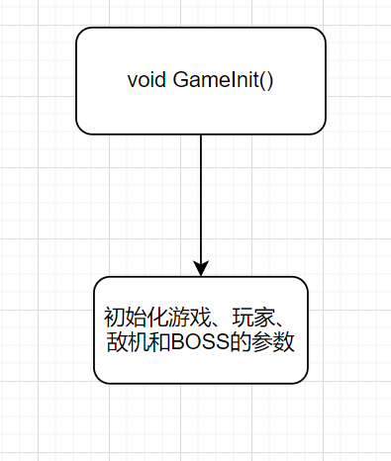

(10)

void CreatEnemyBullet(int i)

{

static int k[ENEMY_NUM];

if (enemy[i].type == 4)

{

for (int j = k[i]; j < enemy[i].bulletnum; j++)

{

if ((!enemybullet[i][j].live && enemy[i].x >= 0.2 * enemy[i].width && enemy[i].x <= 0.3 * enemy[i].width) ||

(!enemybullet[i][j].live && enemy[i].x >= WINDOWWIDTH - 1.3 * enemy[i].width && enemy[i].x <= WINDOWWIDTH - 1.2 * enemy[i].width))

{

enemybullet[i][j].width = img_enemybullet[enemy[i].type - 2].getwidth();

enemybullet[i][j].height = img_enemybullet[enemy[i].type - 2].getheight();

enemybullet[i][j].x = enemy[i].x + enemy[i].width / 2 - enemybullet[i][j].width / 2;

enemybullet[i][j].y = enemy[i].y + enemy[i].height / 2 * 1.3; //调整位置使从炮口射出

enemybullet[i][j].live = 1;

k[i]++;

if (k[i] >= 18) //18发左右摆动子弹

k[i] = 0;

break;

}

}

}

else

{

for (int j = 0; j < enemy[i].bulletnum; j++)

{

if (!enemybullet[i][j].live)

{

if (enemy[i].type == 2)

{

enemybullet[i][j].width = img_enemybullet[enemy[i].type - 2].getwidth();

enemybullet[i][j].height = img_enemybullet[enemy[i].type - 2].getheight();

enemybullet[i][j].x = enemy[i].x + enemy[i].width / 2 - enemybullet[i][j].width / 2;

enemybullet[i][j].y = enemy[i].y + enemy[i].height;

enemybullet[i][j].live = 1;

}

if (enemy[i].type == 3)

{

enemybullet[i][j].x = enemy[i].x + rand() % enemy[i].width; //随机发射

enemybullet[i][j].y = enemy[i].y + enemy[i].height;

enemybullet[i][j].live = 1;

}

break;

}

}

}

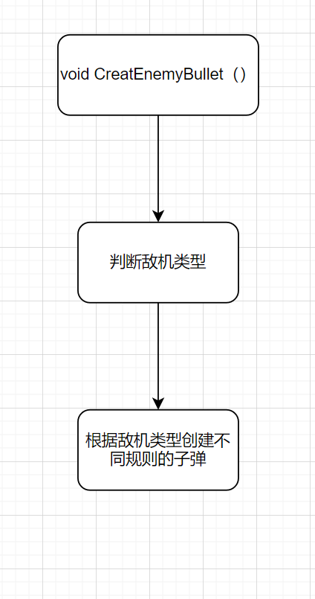

(11)

void CreatPlayerBullet()

{

if (player.type == 3) //发射激光

{

playerbullet[0].bulletlevel = player.bulletlevel;

playerbullet[0].width = img_playerbullet[player.type][player.bulletlevel].getwidth();

playerbullet[0].height = img_playerbullet[player.type][player.bulletlevel].getheight();

playerbullet[0].x = player.x + player.width / 2 - playerbullet[0].width / 2;

playerbullet[0].y = player.y - playerbullet[0].height;

playerbullet[0].live = 1;

}

else

{

for (int i = 0; i < PLAYERBULLET_NUM; i++)

{

if (!playerbullet[i].live)

{

playerbullet[i].width = img_playerbullet[player.type][player.bulletlevel].getwidth();

playerbullet[i].height = img_playerbullet[player.type][player.bulletlevel].getheight();

playerbullet[i].x = player.x + player.width / 2 - playerbullet[i].width / 2;

playerbullet[i].y = player.y - playerbullet[i].height;

playerbullet[i].live = 1;

playerbullet[i].bulletlevel = player.bulletlevel;

break;

}

}

}

}

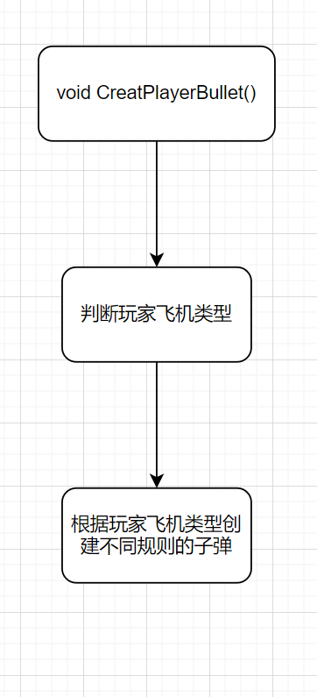

(12)

void CreatEnemy()

{

for (int i = 0; i < ENEMY_NUM; i++)

{

int j = 0;

for (; j < ENEMYBULLET_NUM; j++) //如果该敌机所有子弹都已消失才能创建该敌机

{

if (enemybullet[i][j].live)

break;

}

if (!enemy[i].live && j >= ENEMYBULLET_NUM)

{

EnemyAttribute(i);

enemy[i].live = 1;

break;

}

}

}

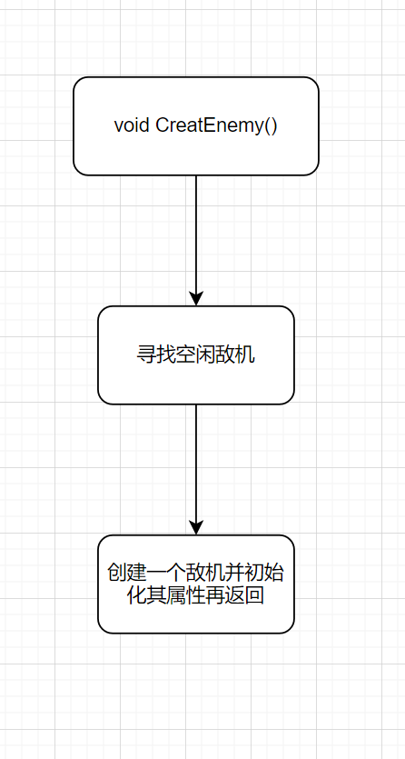

(13)

void PlayerBulletMove()

{

if (player.type == 3 && playerbullet[0].live) //激光不往上移动

{

playerbullet[0].x = player.x + player.width / 2 - playerbullet[0].width / 2;

playerbullet[0].y = -(playerbullet[0].height - player.y);

}

else

{

for (int i = 0; i < PLAYERBULLET_NUM; i++)

{

if (playerbullet[i].live)

{

playerbullet[i].y -= player.bulletspeed;

if (playerbullet[i].y + playerbullet[0].height < 0)

{

playerbullet[i].live = 0;

}

}

}

}

if (supply[0].live == 1) //炸弹移动

{

static int t = 0;

supply[0].y -= 2;

t++;

if (t >= 150 || supply[0].y <= 0)

{

DrawImage(&img_bombbomb, supply[0].x, supply[0].y);

t = 0;

supply[0].live = 0;

supply[0].x = 0;

supply[0].y = 35;

for (int i = 0; i < ENEMY_NUM; i++)

{

if (enemy[i].live)

enemy[i].live = 2;

}

}

}

if (supply[1].live == 1) //子弹速度翻倍

{

player.bulletspeed *= 2;

player.bullettime /= 2;

supply[1].live = 2;

}

if (supply[1].live == 2) //狂暴持续时间

{

static int k; //用动态数组应该能更好的解决这个问题，这样的话有上限，虽然一般不会达到上限

if (TimerOne(10000, 4, k))

{

supply[1].live = 0;

player.bulletspeed /= 2;

player.bullettime *= 2;

}

}

if (supply[3].live == 1) //护盾持续时间

{

static int k; //用动态数组应该能更好的解决这个问题，这样的话有上限，虽然一般不会达到上限

if (TimerOne(6000, 3, k))

{

k++;

supply[3].live = 0;

}

}

}

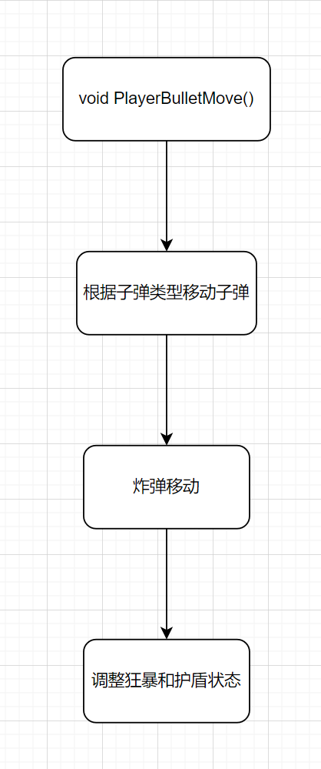

(14)

void EnemyBulletMove()

{

for (int i = 0; i < ENEMY_NUM; i++)

{

for (int j = 0; j < ENEMYBULLET_NUM; j++)

{

if (enemybullet[i][j].live)

{

if (enemy[i].type == 4)

{

enemybullet[i][j].x += enemybullet[i][j].bulletspeed;

enemybullet[i][j].y += 2;

}

else

{

enemybullet[i][j].y += enemybullet[i][j].bulletspeed;

}

if (enemybullet[i][j].y > WINDOWHEIGHT)

{

enemybullet[i][j].live = 0; //出屏幕子弹消失

}

}

}

}

}

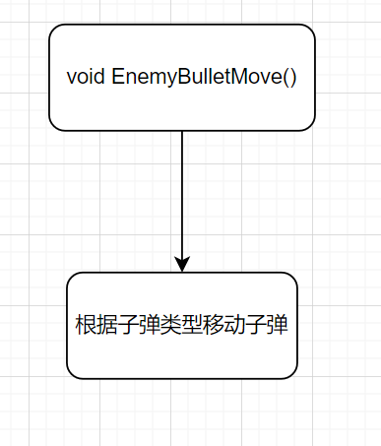

(15)

void PlayerMove(int speed, ExMessage* msg)

{

if (player.live == 1)

{

player.x = msg->x - player.width / 2;

player.y = msg->y - player.height / 2;

//if (GetAsyncKeyState(VK_UP) || (GetAsyncKeyState('W'))) //使用Windows函数获取键盘输入

//{

// if (player.y >= player.height / 2)

// player.y -= speed;

//}

//if (GetAsyncKeyState(VK_DOWN) || (GetAsyncKeyState('S')))

//{

// if (player.y <= WINDOWHEIGHT - player.height) //要减去一个飞机的高度

// player.y += speed;

//}

//if (GetAsyncKeyState(VK_LEFT) || (GetAsyncKeyState('A')))

//{

// if (player.x + player.width * 0.9 / 2 > 0) //加上半个飞机宽度使得飞机能够打到两边的敌人

// player.x -= speed;

//}

//if (GetAsyncKeyState(VK_RIGHT) || (GetAsyncKeyState('D')))

//{

// if (player.x + player.width * 1.1 / 2 < WINDOWWIDTH)

// player.x += speed;

//}

if (supply[0].live == 2)

{

if (GetAsyncKeyState(VK_SPACE)) //发射炸弹

{

supply[0].live = 1;

supply[0].x = player.x + player.width / 2 - supply[0].width / 2;

supply[0].y = player.y - supply[0].height;

}

}

supply[3].x = player.x + player.width / 2 - supply[3].width / 2; //修改护盾位置

supply[3].y = player.y + player.height / 2 - supply[3].height / 2;

if (TimerOne(player.bullettime, 0, 1))

{

CreatPlayerBullet();

}

}

}

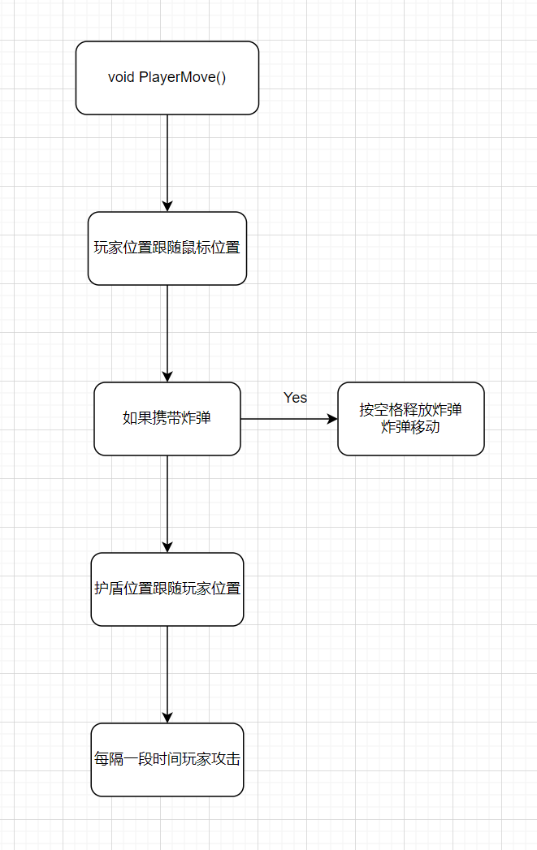

(16)

void EnemyMove()

{

for (int i = 0; i < ENEMY_NUM; i++)

{

if (enemy[i].live)

{

if (enemy[i].type == 3)

{

if (enemy[i].y <= 2.2 * enemy[i].height) //从上面来停在前面

enemy[i].y += enemy[i].speed;

}

else if (enemy[i].type == 4) //随机在左右来

{

if (enemy[i].x <= 0.2 * enemy[i].width)

enemy[i].x += enemy[i].speed;

else if (enemy[i].x >= WINDOWWIDTH - 1.2 * enemy[i].width)

enemy[i].x -= enemy[i].speed;

}

else

{

enemy[i].y += enemy[i].speed;

if (enemy[i].y > WINDOWHEIGHT)

{

enemy[i].live = 0;

}

}

}

}

}

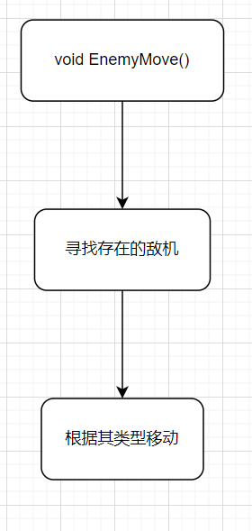

(17)

void SupplyDropMove()

{

for (int i = 0; i < SUPPLY_NUM; i++)

{

if (supplydrop[i].live == 1)

{

supplydrop[i].x += supplydrop[i].bulletspeed; //x轴速度

supplydrop[i].y += supplydrop[i].speed; //y轴速度

if (supplydrop[i].x <= 0 || supplydrop[i].x + supplydrop[i].width >= WINDOWWIDTH) //碰壁反弹

supplydrop[i].bulletspeed = -supplydrop[i].bulletspeed;

if (supplydrop[i].y <= 0 || supplydrop[i].y + supplydrop[i].height >= WINDOWHEIGHT)

supplydrop[i].speed = -supplydrop[i].speed;

}

}

}

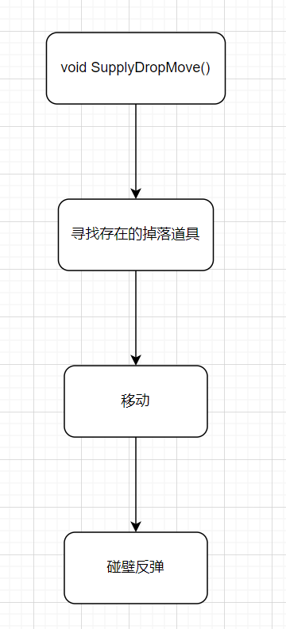

(18)

void BulletLevel()

{

if (gamer.score <= 100)

{

player.bulletlevel = 0;

}

else if (gamer.score > 100 && player.bulletlevel == 0)

{

player.bulletlevel = 1;

player.bullettime /= 2;

player.firepower *= 2;

playerbullet[0].width = img_playerbullet[player.type][player.bulletlevel].getwidth();

playerbullet[0].height = img_playerbullet[player.type][player.bulletlevel].getheight();

for (int i = 1; i < PLAYERBULLET_NUM; i++) //更新子弹宽度和高度

{

playerbullet[i].width = playerbullet[0].width;

playerbullet[i].height = playerbullet[0].height;

}

}

else if (gamer.score > 500 && player.bulletlevel == 1 && player.type != 3)

{

player.bulletlevel = 2;

player.bullettime /= 2;

player.firepower *= 2;

player.bulletspeed *= 2;

playerbullet[0].width = img_playerbullet[player.type][player.bulletlevel].getwidth();

playerbullet[0].height = img_playerbullet[player.type][player.bulletlevel].getheight();

for (int i = 1; i < PLAYERBULLET_NUM; i++) //更新子弹宽度和高度

{

playerbullet[i].width = playerbullet[0].width;

playerbullet[i].height = playerbullet[0].height;

}

}

}

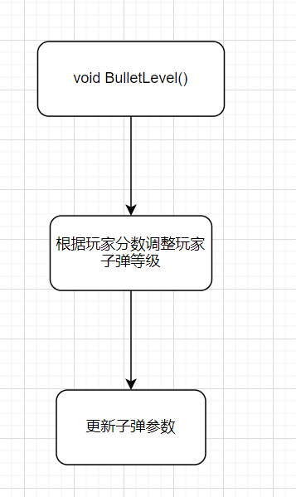

(19)

void Hit()

{

for (int i = 0; i < ENEMY_NUM; i++) //子弹击中敌机

{

if (enemy[i].live != 1)

continue;

for (int j = 0; j < PLAYERBULLET_NUM; j++)

{

if (!playerbullet[j].live)

continue;

if (playerbullet[j].x + playerbullet[j].width < enemy[i].x || playerbullet[j].x > enemy[i].x + enemy[i].width)

continue;

if (playerbullet[j].y + playerbullet[j].height < enemy[i].y || playerbullet[j].y > enemy[i].y + enemy[i].height)

continue;

if (player.type != 3)

{

playerbullet[j].live = 0;

enemy[i].hp -= player.firepower;

}

else if (TimerZero(player.bullettime, 1, i))

enemy[i].hp -= player.firepower;

if (enemy[i].hp <= 0)

{

enemy[i].live = 2;

}

}

}

for (int i = 0; i < BOSS_NUM; i++) //子弹击中BOSS

{

if (boss[i].live != 1)

continue;

for (int j = 0; j < PLAYERBULLET_NUM; j++)

{

if (!playerbullet[j].live)

continue;

if (playerbullet[j].x + playerbullet[j].width < boss[i].x || playerbullet[j].x > boss[i].x + boss[i].width * 0.8)

continue;

if (playerbullet[j].y + playerbullet[j].height < boss[i].y || playerbullet[j].y > boss[i].y + boss[i].height * 0.8)

continue;

if (player.type != 3)

{

playerbullet[j].live = 0;

boss[i].hp -= player.firepower;

gamer.score += player.firepower;

hitboss.score += player.firepower;

}

else if (TimerZero(player.bullettime, 0, 3))

{

boss[i].hp -= player.firepower;

gamer.score += player.firepower;

hitboss.score += player.firepower;

}

if (rand() % 60 == 0) //六十分之一概率掉落四个中的一个道具

{

int randsupply = rand() % 4;

if (supplydrop[randsupply].live || supply[randsupply].live)

continue;

supplydrop[randsupply].live = 1;

supplydrop[randsupply].x = boss[ifdifficult - 1].x + boss[ifdifficult - 1].width / 2;

if (boss[ifdifficult - 1].y > 0) //防止道具卡在屏幕外

supplydrop[randsupply].y = boss[ifdifficult - 1].y + boss[ifdifficult - 1].height / 2;

else

supplydrop[randsupply].y = 0;

}

if (boss[i].hp <= 0)

{

boss[i].live = 2;

}

}

}

if (player.live) //玩家碰撞

{

for (int i = 0; i < ENEMY_NUM; i++) //碰撞敌机

{

if (supply[3].live)

continue;

if (enemy[i].live != 1)

continue;

if (player.x + player.width * 0.9 < enemy[i].x || player.x > enemy[i].x + enemy[i].width * 0.8) // x轴无交集,乘以0.8为了有更好的操作空间

continue;

if (player.y + player.height * 0.9 < enemy[i].y || player.y > enemy[i].y + enemy[i].height * 0.8) // y轴无交集

continue;

if (supply[3].live == 0) //如果不存在护盾

{

if (TimerZero(1000, 0, 0)) //短暂无敌

{

invincibility[0] = 1; //玩家飞机闪烁

invincibility[1] = 1;

player.hp--;

}

}

if (player.hp <= 0)

{

player.live = 2;

}

}

for (int i = 0; i < BOSS_NUM; i++) //碰撞BOSS

{

if (supply[3].live)

continue;

if (boss[i].live != 1)

continue;

if (player.x + player.width * 0.9 < boss[i].x || player.x > boss[i].x + boss[i].width * 0.8)

continue;

if (player.y + player.height * 0.9 < boss[i].y || player.y > boss[i].y + boss[i].height * 0.8)

continue;

if (supply[3].live == 0) //如果不存在护盾

{

if (TimerZero(1000, 0, 0)) //短暂无敌

{

invincibility[0] = 1; //玩家飞机闪烁

invincibility[1] = 1;

player.hp--;

}

}

if (player.hp <= 0)

{

player.live = 2;

}

}

for (int i = 0; i < ENEMY_NUM; i++) //敌机子弹击中玩家

{

for (int j = 0; j < ENEMYBULLET_NUM; j++)

{

if (enemybullet[i][j].live)

{

if (player.x + player.width * 0.7 < enemybullet[i][j].x || player.x + 0.3 * player.width > enemybullet[i][j].x + enemybullet[i][j].width * 0.9) //敌机子弹对我方碰撞只有中间的40%，提高游戏体验

continue;

if (player.y + player.height * 0.7 < enemybullet[i][j].y || player.y + 0.3 * player.width > enemybullet[i][j].y + enemybullet[i][j].height * 0.9)

continue;

enemybullet[i][j].live = 0;

if (supply[3].live == 0) //如果不存在护盾

{

if (TimerZero(1000, 0, 0)) //短暂无敌

{

invincibility[0] = 1; //玩家飞机闪烁

invincibility[1] = 1;

player.hp--;

}

}

if (player.hp <= 0)

{

player.live = 2;

}

}

}

}

for (int i = 0; i < BOSS_NUM; i++) //BOSS子弹击中玩家

{

for (int j = 0; j < BOSSBULLET_NUM; j++)

{

if (bossbullet[i][j].live)

{

if (player.x + player.width * 0.7 < bossbullet[i][j].x || player.x + 0.3 * player.width > bossbullet[i][j].x + bossbullet[i][j].width * 0.8) //BOSS子弹对我方碰撞只有中间的40%，提高游戏体验

continue;

if (player.y + player.height * 0.7 < bossbullet[i][j].y || player.y + 0.3 * player.width > bossbullet[i][j].y + bossbullet[i][j].height * 0.8)

continue;

bossbullet[i][j].live = 0;

if (supply[3].live == 0) //如果不存在护盾

{

if (TimerZero(1000, 0, 0)) //短暂无敌

{

invincibility[0] = 1; //玩家飞机闪烁

invincibility[1] = 1;

player.hp--;

}

}

if (player.hp <= -10)

{

player.live = 2;

}

}

}

}

for (int i = 0; i < BOSSBOMB_NUM; i++) //BOSS导弹击中玩家

{

if (bossbomb[i].live)

{

if (player.x + player.width * 0.9 < bossbomb[i].x || player.x > bossbomb[i].x + bossbomb[i].width * 0.9) // x轴无交集

continue;

if (player.y + player.height * 0.9 < bossbomb[i].y || player.y > bossbomb[i].y + bossbomb[i].height * 0.9) // y轴无交集

continue;

if (supply[3].live == 0) //如果不存在护盾

if (TimerZero(1000, 0, 0)) //短暂无敌

{

invincibility[0] = 1; //玩家飞机闪烁

invincibility[1] = 1;

player.hp--;

}

}

if (player.hp <= 0)

{

player.live = 2;

}

}

for (int i = 0; i < SUPPLY_NUM; i++) //拾到道具

{

if (supplydrop[i].live != 1)

continue;

if (player.x + player.width * 0.9 < supplydrop[i].x || player.x > supplydrop[i].x + supplydrop[i].width)

continue;

if (player.y + player.height * 0.9 < supplydrop[i].y || player.y > supplydrop[i].y + supplydrop[i].height)

continue;

supply[i].live = 1;

if (i == 0) //准备炸弹

supply[i].live = 2;

if (i == 1)

{

thread musicThread(PlayMusic, "./res/media/rage.wav");

musicThread.detach();

}

if (i == 2 && player.hp < 10) //存在bug，五滴血的飞机会加到六滴血，有时间再修

{

thread musicThread(PlayMusic, "./res/media/restore.wav");

musicThread.detach();

player.hp++;

}

if (i == 3)

{

thread musicThread(PlayMusic, "./res/media/shield.wav");

musicThread.detach();

}

supplydrop[i].live = 0;

}

}

}

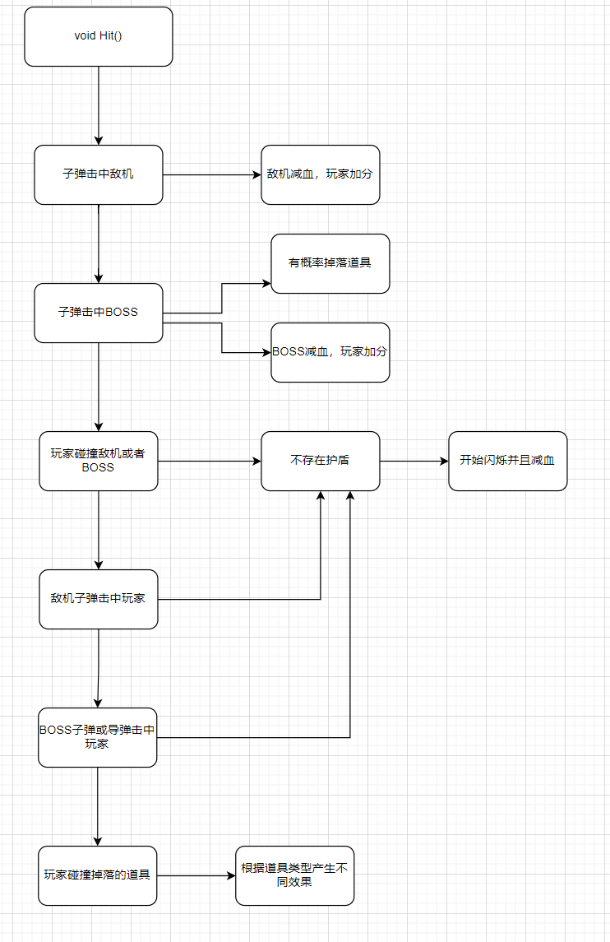

(20)

void ChosePlane(ExMessage* msg)

{

static int choseplanenow = 0;

static int difficult[3];

static int ifouttext;

player.type = choseplanenow; //飞机类型为当前选中飞机

player.width = img_plane[player.type].getwidth();

player.height = img_plane[player.type].getheight();

playerbullet[0].width = img_playerbullet[player.type][player.bulletlevel].getwidth();

playerbullet[0].height = img_playerbullet[player.type][player.bulletlevel].getheight();

player.x = (WINDOWWIDTH - player.width) / 2;

player.y = 571;

if (player.type == 3) //激光战机演示要删除别的子弹

{

for (int i = 1; i < PLAYERBULLET_NUM; i++)

{

playerbullet[i].live = 0;

}

}

for (int i = 1; i < PLAYERBULLET_NUM; i++) //更新子弹宽度和高度

{

playerbullet[i].width = playerbullet[0].width;

playerbullet[i].height = playerbullet[0].height;

}

switch (player.type)

{

case 0:

player.hp = 10;

player.bulletspeed = 2;

player.bullettime = 1000;

player.firepower = 2;

break;

case 1:

player.hp = 5;

player.bulletspeed = 4;

player.bullettime = 500;

player.firepower = 1;

break;

case 2:

player.hp = 10;

player.bulletspeed = 2;

player.bullettime = 2000;

player.firepower = 4;

break;

case 3:

player.hp = 5;

player.bullettime = 800;

player.firepower = 1;

break;

}

putimage(0, 0, &img_choseplanebackground);

DrawImage(&img_choseplane[choseplanenow], 0, 0);

DrawImage(&img_difficulty[0][difficult[0]], 343, 200);

DrawImage(&img_difficulty[1][difficult[1]], 343, 306);

DrawImage(&img_difficulty[2][difficult[2]], 343, 412);

DrawImage(&img_plane[choseplanenow], (WINDOWWIDTH - img_plane[player.type].getwidth()) / 2, 571);

if (IsMouse(msg, 343, 218, 506, 260))

{

difficult[0] = 1;

if (msg->message == WM_LBUTTONDOWN && TimerZero(300, 0, 2)) //难度为普通难度

{

thread musicThread(PlayMusic, "./res/media/click.wav");

musicThread.detach();

ifdifficult = 1; //是否已经选择难度，且难度为ifdifficult

}

}

else

{

difficult[0] = 0;

}

if (IsMouse(msg, 343, 327, 506, 359))

{

difficult[1] = 1;

if (msg->message == WM_LBUTTONDOWN && TimerZero(300, 0, 2)) //难度为炼狱难度

{

thread musicThread(PlayMusic, "./res/media/click.wav");

musicThread.detach();

ifdifficult = 2;

}

}

else

{

difficult[1] = 0;

}

if (IsMouse(msg, 343, 429, 506, 471))

{

difficult[2] = 1;

if (msg->message == WM_LBUTTONDOWN && TimerZero(300, 0, 2)) //难度为英雄难度

{

thread musicThread(PlayMusic, "./res/media/click.wav");

musicThread.detach();

ifdifficult = 3;

}

}

else

{

difficult[2] = 0;

}

difficult[ifdifficult - 1] = 1;

if (IsMouse(msg, 418, 588, 460, 672))

{

if (msg->message == WM_LBUTTONDOWN && TimerZero(300, 0, 2)) //下一个飞机

{

thread musicThread(PlayMusic, "./res/media/click.wav");

musicThread.detach();

choseplanenow++;

}

}

if (IsMouse(msg, 36, 588, 78, 672))

{

if (msg->message == WM_LBUTTONDOWN && TimerZero(300, 0, 2)) //上一个飞机

{

thread musicThread(PlayMusic, "./res/media/click.wav");

musicThread.detach();

choseplanenow--;

}

}

if (choseplanenow == 3)

{

playerbullet[0].x = player.x + player.width / 2 - playerbullet[0].width / 2;

playerbullet[0].y = player.y - playerbullet[0].height;

}

if (choseplanenow < 0) //循环翻页

choseplanenow = 3;

if (choseplanenow > 3)

choseplanenow = 0;

if (IsMouse(msg, 140, 778, 354, 823))

{

DrawImage(&img_battle[1], 137, 783);

if (msg->message == WM_LBUTTONDOWN && ifdifficult == 0)

{

thread musicThread(PlayMusic, "./res/media/click.wav");

musicThread.detach();

ifouttext = 1;

}

else if (msg->message == WM_LBUTTONDOWN && TimerZero(300, 0, 2) && ifdifficult != 0) //出击

{

mciSendString("close ./res/media/menu.wav", NULL, NULL, NULL);

mciSendString("open ./res/media/battle.wav type MPEGVideo", NULL, NULL, NULL);

mciSendString("play ./res/media/battle.wav repeat", NULL, NULL, NULL);

thread musicThread(PlayMusic, "./res/media/go.wav");

musicThread.detach();

GameInit();

SCENE = BATTLE;

}

}

else

{

DrawImage(&img_battle[0], 137, 776);

}

if (ifouttext && ifdifficult == 0)

{

settextcolor(WHITE);

setbkmode(TRANSPARENT);

settextstyle(23, 0, "宋体");

outtextxy(190, 730, "请选择难度");

}

if (TimerOne(player.bullettime, 0, 4))

{

static int showbulletnum;

CreatPlayerBullet(); //创建演示子弹

showbulletnum++;

if (TimerOne(3000, 0, 11))

{

player.bulletlevel++;

if (player.bulletlevel == 3)

player.bulletlevel = 2;

if (player.type = 3 && player.bulletlevel == 2) //激光战机只有两级

player.bulletlevel = 1;

}

if (player.bulletlevel == 3)

player.bulletlevel = 0;

}

for (int i = 0; i < PLAYERBULLET_NUM; i++)

{

if (playerbullet[i].live) //绘制子弹

{

DrawImage(&img_playerbullet[player.type][playerbullet[i].bulletlevel], playerbullet[i].x, playerbullet[i].y);

}

}

PlayerBulletMove();

}

(21)

void Load(const char* filename)

{

FILE* fp = fopen(filename, "r");

if (!fp)

{

printf("%s open failed:%s\n", filename, strerror(errno));

return;

}

char buf[BUFSIZ];

while (!feof(fp)) //读取文件

{

char role[50];

char thing[50];

double doubledata;

int data;

if (!fgets(buf, BUFSIZ, fp))

break;

if (sscanf(buf + 1, "%s", role) == 0)

continue;

if (strcmp(role, "player\0") == 0) //载入玩家数据

{

if (!fgets(buf, BUFSIZ, fp))

break;

if (sscanf(buf, "%s = %lf", thing, &doubledata) == 0)

break;

player.x = doubledata;

if (!fgets(buf, BUFSIZ, fp))

break;

if (sscanf(buf, "%s = %lf", thing, &doubledata) == 0)

break;

player.y = doubledata;

if (!fgets(buf, BUFSIZ, fp))

break;

if (sscanf(buf, "%s = %d", thing, &data) == 0)

break;

player.live = data;

if (!fgets(buf, BUFSIZ, fp))

break;

if (sscanf(buf, "%s = %d", thing, &data) == 0)

break;

player.hp = data;

if (!fgets(buf, BUFSIZ, fp))

break;

if (sscanf(buf, "%s = %lf", thing, &doubledata) == 0)

break;

player.speed = doubledata;

if (!fgets(buf, BUFSIZ, fp))

break;

if (sscanf(buf, "%s = %d", thing, &data) == 0)

break;

player.type = data;

if (!fgets(buf, BUFSIZ, fp))

break;

if (sscanf(buf, "%s = %d", thing, &data) == 0)

break;

player.bulletlevel = data;

if (!fgets(buf, BUFSIZ, fp))

break;

if (sscanf(buf, "%s = %lf", thing, &doubledata) == 0)

break;

player.bulletspeed = doubledata;

if (!fgets(buf, BUFSIZ, fp))

break;

if (sscanf(buf, "%s = %d", thing, &data) == 0)

break;

player.bullettime = data;

if (!fgets(buf, BUFSIZ, fp))

break;

if (sscanf(buf, "%s = %d", thing, &data) == 0)

break;

player.firepower = data;

}

if (!fgets(buf, BUFSIZ, fp))

break;

if (sscanf(buf + 1, "%s", role) == 0)

continue;

if (strcmp(role, "playerbullet\0") == 0) //载入玩家子弹

{

for (int i = 0; i < PLAYERBULLET_NUM; i++)

{

if (!fgets(buf, BUFSIZ, fp))

break;

if (!fgets(buf, BUFSIZ, fp))

break;

if (sscanf(buf, " %s = %lf", thing, &doubledata) == 0)

break;

playerbullet[i].x = doubledata;

if (!fgets(buf, BUFSIZ, fp))

break;

if (sscanf(buf, " %s = %lf", thing, &doubledata) == 0)

break;

playerbullet[i].y = doubledata;

if (!fgets(buf, BUFSIZ, fp))

break;

if (sscanf(buf, " %s = %d", thing, &data) == 0)

break;

playerbullet[i].live = data;

if (!fgets(buf, BUFSIZ, fp))

break;

if (sscanf(buf, " %s = %lf", thing, &doubledata) == 0)

break;

playerbullet[i].bulletspeed = doubledata;

if (!fgets(buf, BUFSIZ, fp))

break;

if (sscanf(buf, " %s = %d", thing, &data) == 0)

break;

playerbullet[i].bulletlevel = data;

}

}

if (!fgets(buf, BUFSIZ, fp))

break;

if (sscanf(buf + 1, "%s", role) == 0)

continue;

if (strcmp(role, "enemy\0") == 0) //载入敌机

{

for (int i = 0; i < ENEMY_NUM; i++)

{

if (!fgets(buf, BUFSIZ, fp))

break;

if (!fgets(buf, BUFSIZ, fp))

break;

if (sscanf(buf, " %s = %lf", thing, &doubledata) == 0)

break;

enemy[i].x = doubledata;

if (!fgets(buf, BUFSIZ, fp))

break;

if (sscanf(buf, " %s = %lf", thing, &doubledata) == 0)

break;

enemy[i].y = doubledata;

if (!fgets(buf, BUFSIZ, fp))

break;

if (sscanf(buf, " %s = %d", thing, &data) == 0)

break;

enemy[i].live = data;

if (!fgets(buf, BUFSIZ, fp))

break;

if (sscanf(buf, " %s = %d", thing, &data) == 0)

break;

enemy[i].hp = data;

if (!fgets(buf, BUFSIZ, fp))

break;

if (sscanf(buf, " %s = %d", thing, &data) == 0)

break;

enemy[i].type = data;

if (!fgets(buf, BUFSIZ, fp))

break;

if (sscanf(buf, " %s = %lf", thing, &doubledata) == 0)

break;

enemy[i].speed = doubledata;

}

}

if (!fgets(buf, BUFSIZ, fp))

break;

if (sscanf(buf + 1, "%s", role) == 0)

continue;

if (strcmp(role, "enemybullet\0") == 0) //载入敌机子弹

{

for (int i = 0; i < ENEMY_NUM; i++)

{

for (int j = 0; j < ENEMYBULLET_NUM; j++)

{

if (!fgets(buf, BUFSIZ, fp))

break;

if (!fgets(buf, BUFSIZ, fp))

break;

if (sscanf(buf, " %s = %lf", thing, &doubledata) == 0)

break;

enemybullet[i][j].x = doubledata;

if (!fgets(buf, BUFSIZ, fp))

break;

if (sscanf(buf, " %s = %lf", thing, &doubledata) == 0)

break;

enemybullet[i][j].y = doubledata;

if (!fgets(buf, BUFSIZ, fp))

break;

if (sscanf(buf, " %s = %d", thing, &data) == 0)

break;

enemybullet[i][j].live = data;

if (!fgets(buf, BUFSIZ, fp))

break;

if (sscanf(buf, " %s = %lf", thing, &doubledata) == 0)

break;

enemybullet[i][j].speed = doubledata;

if (!fgets(buf, BUFSIZ, fp))

break;

if (sscanf(buf, " %s = %lf", thing, &doubledata) == 0)

break;

enemybullet[i][j].bulletspeed = doubledata;

}

}

}

if (!fgets(buf, BUFSIZ, fp))

break;

if (sscanf(buf + 1, "%s", role) == 0)

continue;

if (strcmp(role, "boss\0") == 0) //载入BOSS

{

for (int i = 0; i < BOSS_NUM; i++)

{

if (!fgets(buf, BUFSIZ, fp))

break;

if (!fgets(buf, BUFSIZ, fp))

break;

if (sscanf(buf, " %s = %lf", thing, &doubledata) == 0)

break;

boss[i].x = doubledata;

if (!fgets(buf, BUFSIZ, fp))

break;

if (sscanf(buf, " %s = %lf", thing, &doubledata) == 0)

break;

boss[i].y = doubledata;

if (!fgets(buf, BUFSIZ, fp))

break;

if (sscanf(buf, " %s = %d", thing, &data) == 0)

break;

boss[i].live = data;

if (!fgets(buf, BUFSIZ, fp))

break;

if (sscanf(buf, " %s = %d", thing, &data) == 0)

break;

boss[i].hp = data;

}

}

if (!fgets(buf, BUFSIZ, fp))

break;

if (sscanf(buf + 1, "%s", role) == 0)

continue;

if (strcmp(role, "bossbullet\0") == 0) //载入BOSS子弹

{

for (int i = 0; i < BOSS_NUM; i++)

{

for (int j = 0; j < BOSSBULLET_NUM; j++)

{

if (!fgets(buf, BUFSIZ, fp))

break;

if (!fgets(buf, BUFSIZ, fp))

break;

if (sscanf(buf, " %s = %lf", thing, &doubledata) == 0)

break;

bossbullet[i][j].x = doubledata;

if (!fgets(buf, BUFSIZ, fp))

break;

if (sscanf(buf, " %s = %lf", thing, &doubledata) == 0)

break;

bossbullet[i][j].y = doubledata;

if (!fgets(buf, BUFSIZ, fp))

break;

if (sscanf(buf, " %s = %d", thing, &data) == 0)

break;

bossbullet[i][j].live = data;

if (!fgets(buf, BUFSIZ, fp))

break;

if (sscanf(buf, " %s = %lf", thing, &doubledata) == 0)

break;

bossbullet[i][j].speed = doubledata;

if (!fgets(buf, BUFSIZ, fp))

break;

if (sscanf(buf, " %s = %lf", thing, &doubledata) == 0)

break;

bossbullet[i][j].bulletspeed = doubledata;

}

}

}

if (!fgets(buf, BUFSIZ, fp))

break;

if (sscanf(buf + 1, "%s", role) == 0)

continue;

if (strcmp(role, "bossbomb\0") == 0) //载入BOSS导弹

{

for (int i = 0; i < BOSSBOMB_NUM; i++)

{

if (!fgets(buf, BUFSIZ, fp))

break;

if (!fgets(buf, BUFSIZ, fp))

break;

if (sscanf(buf, " %s = %lf", thing, &doubledata) == 0)

break;

bossbomb[i].x = doubledata;

if (!fgets(buf, BUFSIZ, fp))

break;

if (sscanf(buf, " %s = %lf", thing, &doubledata) == 0)

break;

bossbomb[i].y = doubledata;

if (!fgets(buf, BUFSIZ, fp))

break;

if (sscanf(buf, " %s = %d", thing, &data) == 0)

break;

bossbomb[i].live = data;

if (!fgets(buf, BUFSIZ, fp))

break;

if (sscanf(buf, " %s = %lf", thing, &doubledata) == 0)

break;

bossbomb[i].speed = doubledata;

if (!fgets(buf, BUFSIZ, fp))

break;

if (sscanf(buf, " %s = %lf", thing, &doubledata) == 0)

break;

bossbomb[i].bulletspeed = doubledata;

}

}

if (!fgets(buf, BUFSIZ, fp))

break;

if (sscanf(buf + 1, "%s", role) == 0)

continue;

if (strcmp(role, "supply\0") == 0) //载入道具

{

for (int i = 0; i < SUPPLY_NUM; i++)

{

if (!fgets(buf, BUFSIZ, fp))

break;

if (!fgets(buf, BUFSIZ, fp))

break;

if (sscanf(buf, " %s = %lf", thing, &doubledata) == 0)

break;

supply[i].x = doubledata;

if (!fgets(buf, BUFSIZ, fp))

break;

if (sscanf(buf, " %s = %lf", thing, &doubledata) == 0)

break;

supply[i].y = doubledata;

if (!fgets(buf, BUFSIZ, fp))

break;

if (sscanf(buf, " %s = %d", thing, &data) == 0)

break;

supply[i].live = data;

}

}

if (!fgets(buf, BUFSIZ, fp))

break;

if (sscanf(buf + 1, "%s", role) == 0)

continue;

if (strcmp(role, "supplydrop\0") == 0) //载入掉落物

{

for (int i = 0; i < SUPPLY_NUM; i++)

{

if (!fgets(buf, BUFSIZ, fp))

break;

if (!fgets(buf, BUFSIZ, fp))

break;

if (sscanf(buf, " %s = %lf", thing, &doubledata) == 0)

break;

supplydrop[i].x = doubledata;

if (!fgets(buf, BUFSIZ, fp))

break;

if (sscanf(buf, " %s = %lf", thing, &doubledata) == 0)

break;

supplydrop[i].y = doubledata;

if (!fgets(buf, BUFSIZ, fp))

break;

if (sscanf(buf, " %s = %d", thing, &data) == 0)

break;

supplydrop[i].live = data;

}

}

if (!fgets(buf, BUFSIZ, fp))

break;

if (sscanf(buf + 1, "%s", role) == 0)

continue;

if (strcmp(role, "otherdata\0") == 0) //载入其他数据

{

if (!fgets(buf, BUFSIZ, fp))

break;

if (sscanf(buf, " %s = %d", thing, &data) == 0)

break;

ifdifficult = data;

if (!fgets(buf, BUFSIZ, fp))

break;

if (sscanf(buf, " %s = %d", thing, &data) == 0)

break;

ifcreatbossbullet[0] = data;

if (!fgets(buf, BUFSIZ, fp))

break;

if (sscanf(buf, " %s = %d", thing, &data) == 0)

break;

ifcreatbossbullet[1] = data;

if (!fgets(buf, BUFSIZ, fp))

break;

if (sscanf(buf, " %s = %d", thing, &data) == 0)

break;

ifcreatbossbullet[2] = data;

if (!fgets(buf, BUFSIZ, fp))

break;

if (sscanf(buf, " %s = %d", thing, &data) == 0)

break;

invincibility[0] = data;

if (!fgets(buf, BUFSIZ, fp))

break;

if (sscanf(buf, " %s = %d", thing, &data) == 0)

break;

invincibility[1] = data;

if (!fgets(buf, BUFSIZ, fp))

break;

if (sscanf(buf, " %s = %s", thing, thing) == 0)

break;

strcpy(gamer.name, thing);

if (!fgets(buf, BUFSIZ, fp))

break;

if (sscanf(buf, " %s = %d", thing, &data) == 0)

break;

gamer.score = data;

if (!fgets(buf, BUFSIZ, fp))

break;

if (sscanf(buf, " %s = %d", thing, &data) == 0)

break;

hitboss.score = data;

if (!fgets(buf, BUFSIZ, fp))

break;

if (sscanf(buf, " %s = %lf", thing, &doubledata) == 0)

break;

map[ifdifficult - 1].y = doubledata;

}

}

fclose(fp);

}

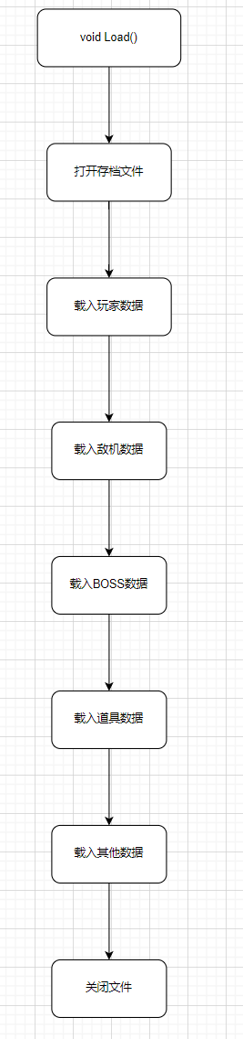

(22)

void Save(const char* filename)

{

FILE* fp = fopen(filename, "w+");

if (!fp)

{

printf("%s open failed:%s\n", filename, strerror(errno));

return;

}

fputs("@player\n", fp); //保存玩家数据

if (!fprintf(fp, "x = %lf\n", player.x))

return;

if (!fprintf(fp, "y = %lf\n", player.y))

return;

if (!fprintf(fp, "live = %d\n", player.live))

return;

if (!fprintf(fp, "hp = %d\n", player.hp))

return;

if (!fprintf(fp, "speed = %lf\n", player.speed))

return;

if (!fprintf(fp, "type = %d\n", player.type))

return;

if (!fprintf(fp, "bulletlevel = %d\n", player.bulletlevel))

return;

if (!fprintf(fp, "bulletspeed = %lf\n", player.bulletspeed))

return;

if (!fprintf(fp, "bullettime = %d\n", player.bullettime))

return;

if (!fprintf(fp, "bulletfirepower = %d\n", player.firepower))

return;

fputs("@playerbullet\n", fp);

for (int i = 0; i < PLAYERBULLET_NUM; i++) //保存玩家子弹

{

if (!fprintf(fp, " @playerbullet[%d]\n", i))

return;

if (!fprintf(fp, " x = %lf\n", playerbullet[i].x))

return;

if (!fprintf(fp, " y = %lf\n", playerbullet[i].y))

return;

if (!fprintf(fp, " live = %d\n", playerbullet[i].live))

return;

if (!fprintf(fp, " bulletspeed = %lf\n", playerbullet[i].bulletspeed))

return;

if (!fprintf(fp, " bulletlevel = %d\n", playerbullet[i].bulletlevel))

return;

}

fputs("@enemy\n", fp); //保存敌机

for (int i = 0; i < ENEMY_NUM; i++)

{

if (!fprintf(fp, " @enemy[%d]\n", i))

return;

if (!fprintf(fp, " x = %lf\n", enemy[i].x))

return;

if (!fprintf(fp, " y = %lf\n", enemy[i].y))

return;

if (!fprintf(fp, " live = %d\n", enemy[i].live))

return;

if (!fprintf(fp, " hp = %d\n", enemy[i].hp))

return;

if (!fprintf(fp, " type = %d\n", enemy[i].type))

return;

if (!fprintf(fp, " speed = %lf\n", enemy[i].speed))

return;

}

fputs("@enemybullet\n", fp); //保存敌机子弹

for (int i = 0; i < ENEMY_NUM; i++)

{

for (int j = 0; j < ENEMYBULLET_NUM; j++)

{

if (!fprintf(fp, " @enemybullet[%d][%d]\n", i, j))

return;

if (!fprintf(fp, " x = %lf\n", enemybullet[i][j].x))

return;

if (!fprintf(fp, " y = %lf\n", enemybullet[i][j].y))

return;

if (!fprintf(fp, " live = %d\n", enemybullet[i][j].live))

return;

if (!fprintf(fp, " speed = %lf\n", enemybullet[i][j].speed))

return;

if (!fprintf(fp, " bulletspeed = %lf\n", enemybullet[i][j].bulletspeed))

return;

}

}

fputs("@boss\n", fp); //保存BOSS

for (int i = 0; i < BOSS_NUM; i++)

{

if (!fprintf(fp, " @boss[%d]\n", i))

return;

if (!fprintf(fp, " x = %lf\n", boss[i].x))

return;

if (!fprintf(fp, " y = %lf\n", boss[i].y))

return;

if (!fprintf(fp, " live = %d\n", boss[i].live))

return;

if (!fprintf(fp, " hp = %d\n", boss[i].hp))

return;

}

fputs("@bossbullet\n", fp); //保存BOSS子弹

for (int i = 0; i < BOSS_NUM; i++)

{

for (int j = 0; j < BOSSBULLET_NUM; j++)

{

if (!fprintf(fp, " @bossbullet[%d][%d]\n", i, j))

return;

if (!fprintf(fp, " x = %lf\n", bossbullet[i][j].x))

return;

if (!fprintf(fp, " y = %lf\n", bossbullet[i][j].y))

return;

if (!fprintf(fp, " live = %d\n", bossbullet[i][j].live))

return;

if (!fprintf(fp, " speed = %lf\n", bossbullet[i][j].speed))

return;

if (!fprintf(fp, " bulletspeed = %lf\n", bossbullet[i][j].bulletspeed))

return;

}

}

fputs("@bossbomb\n", fp); //保存BOSS导弹

for (int i = 0; i < BOSSBOMB_NUM; i++)

{

if (!fprintf(fp, " @bossbomb[%d]\n", i))

return;

if (!fprintf(fp, " x = %lf\n", bossbomb[i].x))

return;

if (!fprintf(fp, " y = %lf\n", bossbomb[i].y))

return;

if (!fprintf(fp, " live = %d\n", bossbomb[i].live))

return;

if (!fprintf(fp, " speed = %lf\n", bossbomb[i].speed))

return;

if (!fprintf(fp, " bulletspeed = %lf\n", bossbomb[i].bulletspeed))

return;

}

fputs("@supply\n", fp); //保存补给状态

for (int i = 0; i < SUPPLY_NUM; i++)

{

if (!fprintf(fp, " @supply[%d]\n", i))

return;

if (!fprintf(fp, " x = %lf\n", supply[i].x))

return;

if (!fprintf(fp, " y = %lf\n", supply[i].y))

return;

if (!fprintf(fp, " live = %d\n", supply[i].live))

return;

}

fputs("@supplydrop\n", fp); //保存掉落补给

for (int i = 0; i < SUPPLY_NUM; i++)

{

if (!fprintf(fp, " @supplydrop[%d]\n", i))

return;

if (!fprintf(fp, " x = %lf\n", supplydrop[i].x))

return;

if (!fprintf(fp, " y = %lf\n", supplydrop[i].y))

return;

if (!fprintf(fp, " live = %d\n", supplydrop[i].live))

return;

}

fputs("@otherdata\n", fp); //保存其他数据

if (!fprintf(fp, " ifdifficult = %d\n", ifdifficult))

return;

if (!fprintf(fp, " ifcreatbossbullet[0] = %d\n", ifcreatbossbullet[0]))

return;

if (!fprintf(fp, " ifcreatbossbullet[1] = %d\n", ifcreatbossbullet[1]))

return;

if (!fprintf(fp, " ifcreatbossbullet[2] = %d\n", ifcreatbossbullet[2]))

return;

if (!fprintf(fp, " invincibility[0] = %d\n", invincibility[0]))

return;

if (!fprintf(fp, " invincibility[1] = %d\n", invincibility[1]))

return;

if (!fprintf(fp, " gamer.name = %s\n", gamer.name))

return;

if (!fprintf(fp, " gamer.score = %d\n", gamer.score))

return;

if (!fprintf(fp, " hitboss.score = %d\n", hitboss.score))

return;

if (!fprintf(fp, " map[ifdifficult - 1].y = %lf\n", map[ifdifficult - 1].y))

return;

fclose(fp);

}

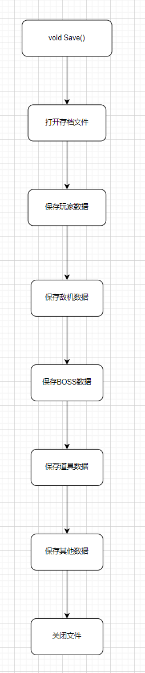

(23)

void LoadList(const char* filename)

{

FILE* fp = fopen(filename, "r");

if (!fp)

{

printf("%s open failed:%s\n", filename, strerror(errno));

return;

}

char buf[BUFSIZ];

while (!feof(fp)) //读取文件

{

if (!fgets(buf, BUFSIZ, fp))

break;

if (!strcmp(buf, "@name @score"))

break;

char namedata[20];

int scoredata;

for (int i = 0; i < 10; i++)

{

if (!fgets(buf, BUFSIZ, fp))

break;

if (sscanf(buf, "%s %d", namedata, &scoredata) == 0)

break;

strcpy(role[i].name, namedata); //读取昵称

role[i].score = scoredata; //读取分数

}

}

fclose(fp);

}

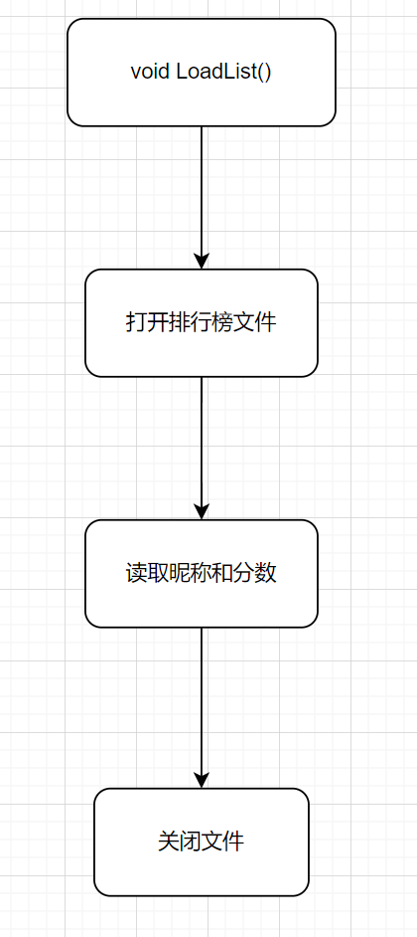

(24)

void SaveList(const char* filename)

{

FILE* fp = fopen(filename, "w+");

if (!fp)

{

printf("%s open failed:%s\n", filename, strerror(errno));

return;

}

fputs("@name @score\n", fp);

for (int i = 0; i < 10; i++)

{

if (!fprintf(fp, "%s %d\n", role[i].name, role[i].score))

return;

}

fclose(fp);

}

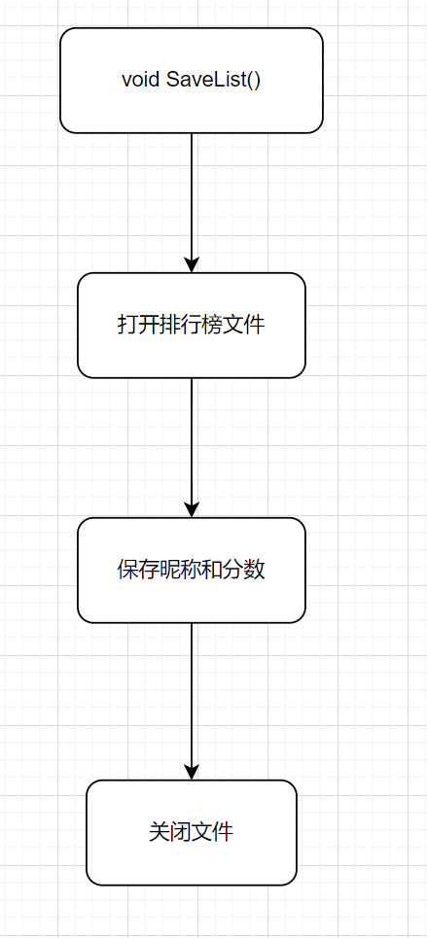

(25)

void SaveScore()

{

int max = 0;

int maxnum = 0;

int tscore = 0;

char tname[20];

role[10].score = gamer.score;

strcpy(role[10].name, gamer.name);

for (int i = 0; i < 11; i++) //排序

{

for (int j = i; j < 11; j++)

{

if (role[j].score > max)

{

max = role[j].score;

maxnum = j;

}

}

tscore = role[i].score;

role[i].score = max;

role[maxnum].score = tscore;

strcpy(tname, role[i].name);

strcpy(role[i].name, role[maxnum].name);

strcpy(role[maxnum].name, tname);

max = 0;

}

SaveList("./scorelist.txt"); //保存到文件

}

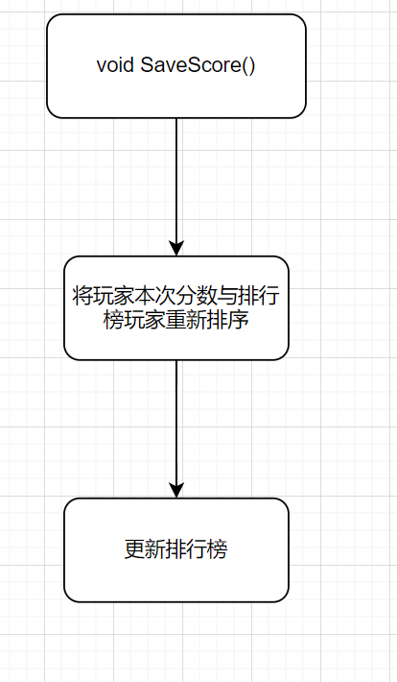

(26)

void CreatBoss()

{

mciSendString("close ./res/media/battle.wav", NULL, NULL, NULL);

mciSendString("open ./res/media/boss.wav type MPEGVideo", NULL, NULL, NULL);

mciSendString("play ./res/media/boss.wav repeat", NULL, NULL, NULL);

thread musicThread(PlayMusic, "./res/media/warning.wav");

musicThread.detach();

boss[ifdifficult - 1].live = 1;

boss[ifdifficult - 1].x = WINDOWWIDTH / 2 - boss[ifdifficult - 1].width / 2;

boss[ifdifficult - 1].y = -boss[ifdifficult - 1].height;

boss[ifdifficult - 1].hp = ifdifficult * 500;

boss[ifdifficult - 1].bulletspeed = 2;

bossbullet[0][0].bulletspeed = 1;

bossbullet[1][0].bulletspeed = 1;

bossbullet[2][0].bulletspeed = 1;

boss[0].bulletnum = 30;

boss[1].bulletnum = 54;

boss[2].bulletnum = 72;

for (int i = 0; i < boss[1].bulletnum; )

{

if (i % 15 == 0)

{

bossbullet[1][i].bulletspeed = 0;

bossbullet[1][i].speed = 2;

i++;

}

for (int k = 0; k < 4; k++, i++)

{

bossbullet[1][i].bulletspeed = bossbullet[1][i - 1].bulletspeed + 0.7;

bossbullet[1][i].speed = 2;

}

for (int k = 0; k < 7; k++, i++)

{

bossbullet[1][i].bulletspeed = bossbullet[1][i - 1].bulletspeed - 0.8;

bossbullet[1][i].speed = 2;

}

for (int k = 0; k < 3; k++, i++)

{

bossbullet[1][i].bulletspeed = bossbullet[1][i - 1].bulletspeed + 0.7;

bossbullet[1][i].speed = 2;

}

}

for (int i = 0, r = 2, smallpartnum = 6; i < boss[2].bulletnum; )

{

for (int k = 0; k < smallpartnum; k++, i++)

{

bossbullet[2][i].speed = -r * cos(PAI / 2 * k / smallpartnum); //y轴子弹速度

bossbullet[2][i].bulletspeed = sqrt(r * r - bossbullet[2][i].speed * bossbullet[2][i].speed); //x轴子弹速度

}

for (int k = 0; k < smallpartnum; k++, i++)

{

bossbullet[2][i].speed = r * sin(PAI / 2 * k / smallpartnum);

bossbullet[2][i].bulletspeed = sqrt(r * r - bossbullet[2][i].speed * bossbullet[2][i].speed);

}

for (int k = 0; k < smallpartnum; k++, i++)

{

bossbullet[2][i].speed = r * cos(PAI / 2 * k / smallpartnum);

bossbullet[2][i].bulletspeed = -sqrt(r * r - bossbullet[2][i].speed * bossbullet[2][i].speed);

}

for (int k = 0; k < smallpartnum; k++, i++)

{

bossbullet[2][i].speed = -r * sin(PAI / 2 * k / smallpartnum);

bossbullet[2][i].bulletspeed = -sqrt(r * r - bossbullet[2][i].speed * bossbullet[2][i].speed);

}

}

}

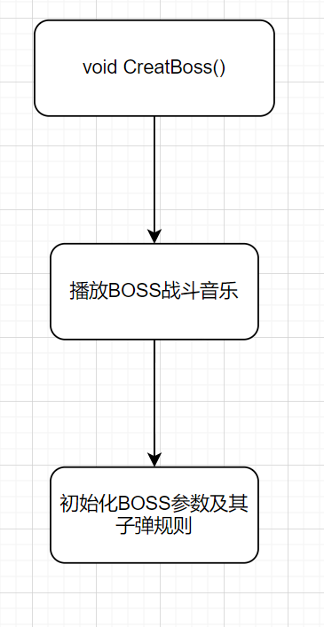

(27)

void CreatBossBulletOne()

{

static int k;

for (int i = 0, j = 0; i < boss[0].bulletnum; i++)

{

if (!bossbullet[0][i].live)

{

bossbullet[0][i].live = 1;

bossbullet[0][i].speed = rand() % 10 / 10 + 1.8;

bossbullet[0][i].x = rand() % boss[0].width;

bossbullet[0][i].y = boss[0].height;

if (rand() % 2)

{

bossbullet[0][i].bulletspeed = rand() % 10 / 10 + 0.3;

}

else

{

bossbullet[0][i].bulletspeed = -rand() % 10 / 10 - 0.3;

}

j++;

k++;

}

if (k >= boss[0].bulletnum)

{

ifcreatbossbullet[0] = 0;

k = 0;

}

if (j >= rand() % 7 + 3) //每次最低3发

break;

}

}

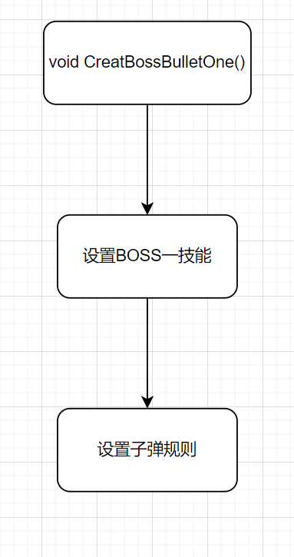

(28)

void CreatBossBulletTwo()

{

static int k;

for (int i = k; i < boss[1].bulletnum; i++)

{

bossbullet[1][i].x = boss[ifdifficult - 1].x + boss[ifdifficult - 1].width / 2 - bossbullet[1][i].width * 0.7;

bossbullet[1][i].y = boss[ifdifficult - 1].y + boss[ifdifficult - 1].height;

bossbullet[1][i].live = 1;

k++;

if (k >= boss[1].bulletnum)

{

ifcreatbossbullet[1] = 0;

k = 0;

}

break;

}

}

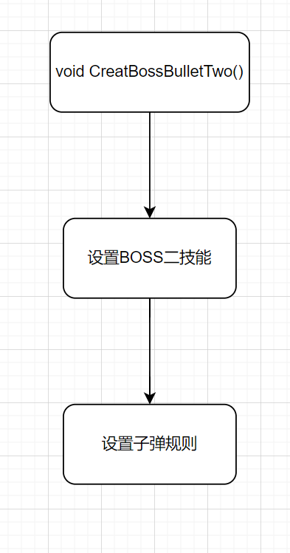

(29)

void CreatBossBulletThree()

{

static int k;

for (int i = k; i < boss[2].bulletnum; i++)

{

bossbullet[2][i].x = boss[ifdifficult - 1].x + boss[ifdifficult - 1].width / 2 - bossbullet[2][i].width * 0.7;

bossbullet[2][i].y = boss[ifdifficult - 1].y + boss[ifdifficult - 1].height;

bossbullet[2][i].live = 1;

k++;

if (k >= boss[2].bulletnum)

{

ifcreatbossbullet[2] = 0;

k = 0;

}

break;

}

}

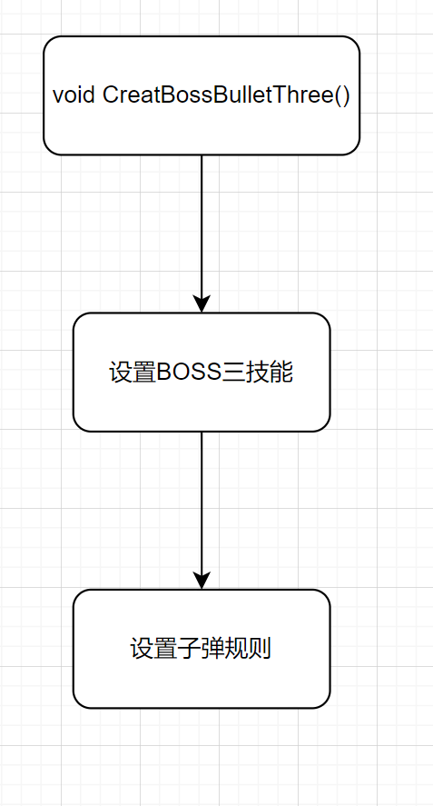

(30)

void CreatBossBomb()

{

for (int i = 0; i < BOSSBOMB_NUM; i++)

{

if (!bossbomb[i].live)

{

bossbomb[i].live = 1;

bossbomb[i].x = player.x;

bossbomb[i].y = -bossbomb[i].height;

}

break;

}

}

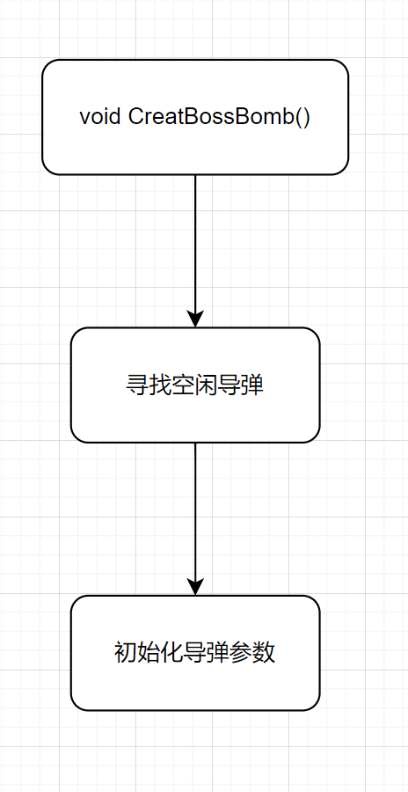

(31)

void BossBulletMove()

{

for (int i = 0; i < 3; i++)

{

for (int j = 0; j < BOSSBULLET_NUM; j++)

{

if (bossbullet[i][j].live)

{

bossbullet[i][j].x += bossbullet[i][j].bulletspeed; //x轴速度

bossbullet[i][j].y += bossbullet[i][j].speed; //y轴速度

if (bossbullet[i][j].x >= WINDOWWIDTH || bossbullet[i][j].x <= 0 || bossbullet[i][j].y >= WINDOWHEIGHT || bossbullet[i][j].y <= 0)

bossbullet[i][j].live = 0;

}

}

}

for (int i = 0; i < BOSSBOMB_NUM; i++)

{

if (bossbomb[i].live)

{

bossbomb[i].y += 3;

}

if (bossbomb[i].y > WINDOWHEIGHT)

{

bossbomb[i].live = 0;

}

}

}

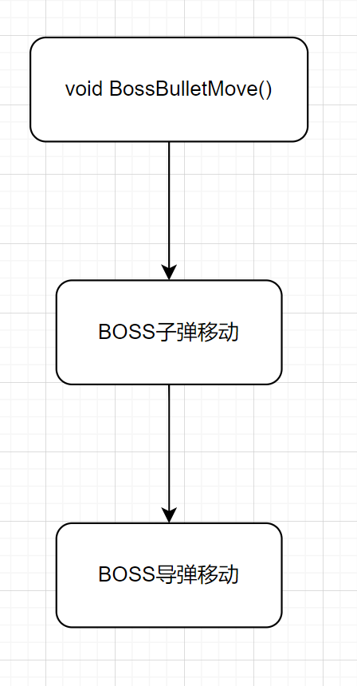

(32)

void BossComing()

{

if (boss[ifdifficult - 1].y <= 0)

{

boss[ifdifficult - 1].y += 1;

}

if (ifcreatbossbullet[0] == 1 && TimerOne(1000, 0, 7))

{

CreatBossBulletOne();

}

if (ifcreatbossbullet[1] == 1 && TimerOne(100, 0, 8))

{

CreatBossBulletTwo();

}

if (ifcreatbossbullet[2] == 1 && TimerOne(30, 0, 9))

{

CreatBossBulletThree();

}

if (TimerOne(8000, 0, 6))

{

if (ifdifficult == 3 && rand() % 10 >= 0 && rand() % 10 <= 5)

{

ifcreatbossbullet[2] = 1;

}

else if (ifdifficult >= 2 && rand() % 10 >= 0 && rand() % 10 <= 5)

{

ifcreatbossbullet[1] = 1;

}

else

{

ifcreatbossbullet[0] = 1;

}

}

if (TimerOne(10000, 0, 10) && ifdifficult == 3)

{

CreatBossBomb();

}

}

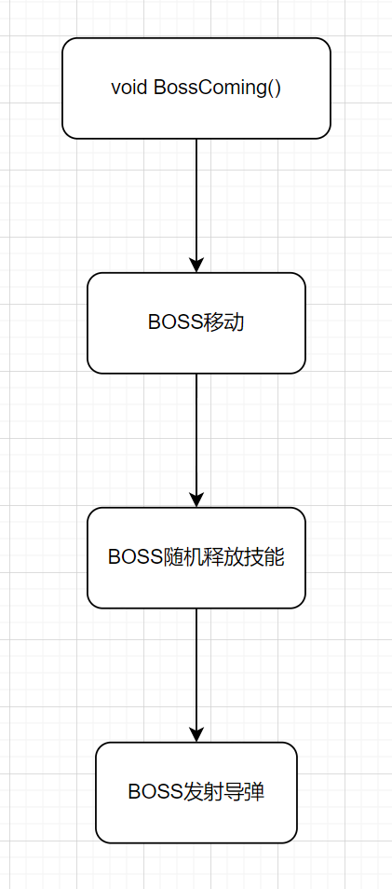

(33)

void GameOver(ExMessage* msg)

{

FlushBatchDraw();

putimage(0, 0, &img_gameover);

char str_score[20];

sprintf(str_score, "%d", gamer.score);

settextcolor(WHITE);

setbkmode(TRANSPARENT);

settextstyle(60, 0, "宋体");

outtextxy(139, 220, str_score);

if (IsMouse(msg, 150, 660, 360, 724))

{

DrawImage(&img_tryagain[1], 150, 660);

if (msg->message == WM_LBUTTONDOWN && TimerZero(300, 0, 2)) //再次挑战

{

mciSendString("close ./res/media/battle.wav", NULL, NULL, NULL);

thread musicThread(PlayMusic, "./res/media/click.wav");

musicThread.detach();

SCENE = GAMESTART;

FlushBatchDraw();

}

}

else

{

DrawImage(&img_tryagain[0], 150, 660);

}

if (IsMouse(msg, 150, 760, 360, 824))

{

DrawImage(&img_returnmenu[1], 150, 760);

if (msg->message == WM_LBUTTONDOWN && TimerZero(300, 0, 2)) //返回菜单

{

thread musicThread(PlayMusic, "./res/media/click.wav");

musicThread.detach();

mciSendString("close ./res/media/battle.wav", NULL, NULL, NULL);

mciSendString("close ./res/media/boss.wav", NULL, NULL, NULL);

mciSendString("open ./res/media/menu.wav type MPEGVideo", NULL, NULL, NULL);

mciSendString("play ./res/media/menu.wav repeat", NULL, NULL, NULL);

SCENE = MENU;

FlushBatchDraw();

}

}

else

{

DrawImage(&img_returnmenu[0], 150, 760);

}

}

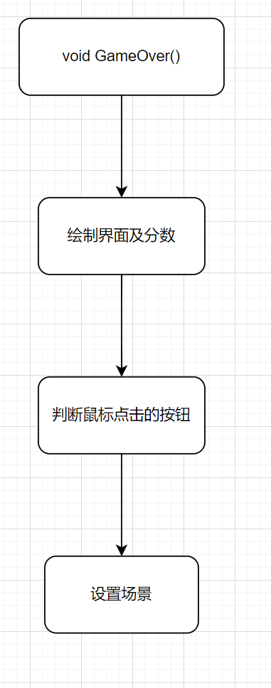

(34)

void GameDraw()

{

putimage(map[ifdifficult - 1].x, map[ifdifficult - 1].y, &img_map[ifdifficult - 1]); //绘制地图

if (player.live == 1) //绘制玩家

{

if (invincibility[0] == 0)

DrawImage(&img_plane[player.type], player.x, player.y);

else

{

if (invincibility[1] == 0) //开始闪烁

{

DrawImage(&img_plane[player.type], player.x, player.y);

if (TimerZero(100, 0, 1))

invincibility[1] = 1;

}

else if (TimerZero(100, 0, 1))

invincibility[1] = 0;

}

}

else if (player.live == 2) //玩家死亡

{

DrawImage(&img_playerdie, player.x, player.y);

thread musicThread(PlayMusic, "./res/media/explode.wav");

musicThread.detach();

if (TimerOne(200, 2, 0))

{

player.live = 0;

SaveScore();

SCENE = GAMEOVER;

}

}

for (int i = 0; i < ENEMY_NUM; i++)

{

if (enemy[i].live == 1)

{

DrawImage(&img_enemy[enemy[i].type], enemy[i].x, enemy[i].y); //绘制敌机

if (TimerOne(enemy[i].bullettime, 1, i)) //敌机发射子弹

CreatEnemyBullet(i);

}

if (enemy[i].live == 2) //敌机死亡

{

DrawImage(&img_enemydie[enemy[i].type], enemy[i].x, enemy[i].y);

thread musicThread(PlayMusic, "./res/media/explode.wav");

musicThread.detach();

if (TimerOne(200, 2, i + 1))

{

gamer.score += (enemy[i].type + 1) * 5;

enemy[i].live = 0;

if (rand() % 10 == 0) //十分之一概率掉落四个中的一个道具

{

int randsupply = rand() % 4;

if (supplydrop[randsupply].live || supply[randsupply].live)

continue;

supplydrop[randsupply].live = 1;

supplydrop[randsupply].x = enemy[i].x;

if (enemy[i].y > 0) //防止道具卡在屏幕外

supplydrop[randsupply].y = enemy[i].y;

else

supplydrop[randsupply].y = 0;

}

}

}

}

for (int i = 0; i < ENEMY_NUM; i++) //绘制敌机子弹

{

for (int j = 0; j < ENEMYBULLET_NUM; j++)

{

if (enemybullet[i][j].live)

{

DrawImage(&img_enemybullet[enemy[i].type - 2], enemybullet[i][j].x, enemybullet[i][j].y);

}

}

}

for (int i = 0; i < BOSS_NUM; i++) //绘制BOSS

{

if (boss[i].live == 1)

{

DrawImage(&img_boss[i], boss[i].x, boss[i].y);

}

else if (boss[i].live == 2) //播放BOSS死亡动画

{

static DWORD t1[ENEMY_NUM], t2[ENEMY_NUM];

if (t1[i] == 0)

t1[i] = clock();

t2[i] = clock();

if (t2[i] - t1[i] >= 0 && t2[i] - t1[i] < 1000)

{

DrawImage(&img_bossdie[i][0], boss[i].x, boss[i].y);

thread musicThread(PlayMusic, "./res/media/explode.wav");

musicThread.detach();

}

if (t2[i] - t1[i] >= 100 && t2[i] - t1[i] < 2000)

{

DrawImage(&img_bossdie[i][1], boss[i].x, boss[i].y);

thread musicThread(PlayMusic, "./res/media/explode.wav");

musicThread.detach();

}

if (t2[i] - t1[i] >= 200 && t2[i] - t1[i] < 3000)

{

DrawImage(&img_bossdie[i][2], boss[i].x, boss[i].y);

thread musicThread(PlayMusic, "./res/media/explode.wav");

musicThread.detach();

mciSendString("close ./res/media/boss.wav", NULL, NULL, NULL);

mciSendString("open ./res/media/battle.wav type MPEGVideo", NULL, NULL, NULL);

mciSendString("play ./res/media/battle.wav repeat", NULL, NULL, NULL);

boss[i].live = 0;

t1[i] = 0;

}

}

}

for (int i = 0; i < BOSS_NUM; i++) //绘制BOSS子弹

{

for (int j = 0; j < BOSSBULLET_NUM; j++)

{

if (bossbullet[i][j].live)

{

DrawImage(&img_bossbullet[i], bossbullet[i][j].x, bossbullet[i][j].y);

}

}

}

for (int i = 0; i < BOSSBOMB_NUM; i++)

{

if (bossbomb[i].live)

DrawImage(&img_bossbomb, bossbomb[i].x, bossbomb[i].y);

}

for (int i = 0; i < PLAYERBULLET_NUM; i++) //绘制玩家子弹

{

if (playerbullet[i].live)

{

DrawImage(&img_playerbullet[player.type][playerbullet[i].bulletlevel], playerbullet[i].x, playerbullet[i].y);

}

}

for (int i = 0; i < SUPPLY_NUM; i++) //绘制道具

{

if (supplydrop[i].live)

{

DrawImage(&img_supplydrop[i], supplydrop[i].x, supplydrop[i].y);

}

if (supply[i].live)

{

DrawImage(&img_supply[i], supply[i].x, supply[i].y);

}

}

DrawImage(&img_state, 0, 0); //绘制状态栏

settextcolor(RGB(255, 239, 111));

setbkmode(TRANSPARENT);

settextstyle(20, 0, "华文新魏");

char str_score[100];

sprintf(str_score, "%d", gamer.score);

outtextxy(410, 8, str_score); //输出分数

char str_hp[10];

sprintf(str_hp, "HP:%d", player.hp);

outtextxy(110, 8, str_hp); //输出玩家血量

}

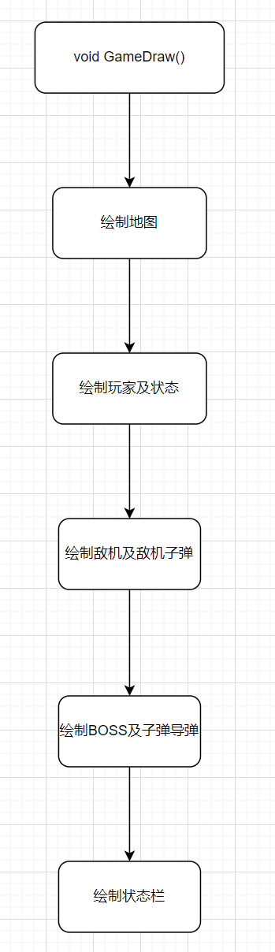

(35)

void GameStart(ExMessage* msg)

{

peekmessage(msg, EM_MOUSE);

ChosePlane(msg); //选择飞机

FlushBatchDraw();

if (!strcmp(gamer.name, "0") || !strcmp(gamer.name, ""))

InputBox(gamer.name, 20, "请输入名字");

}

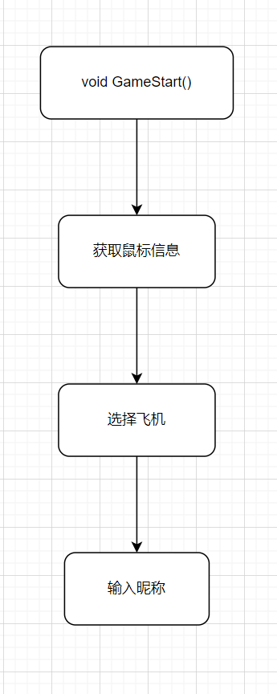

(36)

void GameStop(ExMessage* msg)

{

FlushBatchDraw();

GameDraw();

DrawImage(&img_stop, 0, 0);

if (IsMouse(msg, 150, 500, 359, 564))

{

DrawImage(&img_savegame[1], 150, 500);

if (msg->message == WM_LBUTTONDOWN && TimerZero(300, 0, 2)) //保存游戏

{

thread musicThread(PlayMusic, "./res/media/click.wav");

musicThread.detach();

Save("./data.txt");

}

}

else

{

DrawImage(&img_savegame[0], 150, 500);

}

if (IsMouse(msg, 150, 600, 359, 664))

{

DrawImage(&img_continuegame[1], 150, 600);

if (msg->message == WM_LBUTTONDOWN && TimerZero(300, 0, 2)) //继续游戏

{

thread musicThread(PlayMusic, "./res/media/click.wav");

musicThread.detach();

SCENE = BATTLE;

}

}

else

{

DrawImage(&img_continuegame[0], 150, 600);

}

if (IsMouse(msg, 150, 700, 359, 764))

{

DrawImage(&img_return[1], 150, 700);

if (msg->message == WM_LBUTTONDOWN && TimerZero(300, 0, 2)) //返回菜单

{

thread musicThread(PlayMusic, "./res/media/click.wav");

musicThread.detach();

SCENE = MENU;

}

}

else

{

DrawImage(&img_return[0], 150, 700);

}

}

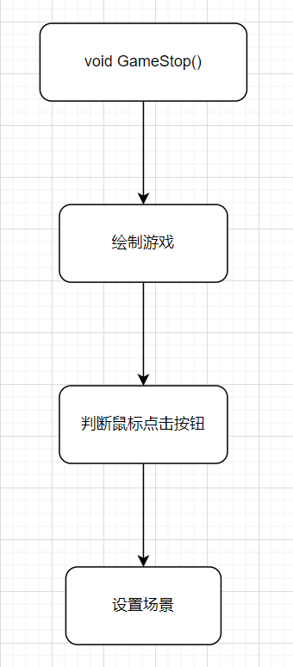

(37)

void Battle(ExMessage* msg)

{

map[ifdifficult - 1].y++;

if (map[ifdifficult - 1].y >= 0)

map[ifdifficult - 1].y = -(map[ifdifficult - 1].height - WINDOWHEIGHT);

if (invincibility[0] == 1 && TimerZero(1000, 0, 0))

{

invincibility[0] = 0; //不再闪烁

invincibility[1] = 0;

}

FlushBatchDraw();

PlayerMove(10, msg);

PlayerBulletMove();

EnemyBulletMove();

EnemyMove();

Hit();

BulletLevel();

SupplyDropMove();

BossBulletMove();

if (gamer.score - hitboss.score % 1000 >= 0 && gamer.score - hitboss.score % 1000 <= 50 && gamer.score != 0 && !boss[ifdifficult - 1].live)

{

CreatBoss();

}

else if (TimerOne(1200, 0, 0) && boss[ifdifficult - 1].live == 0 && player.bulletlevel <= 1)

{

CreatEnemy();

}

else if (TimerOne(600, 0, 5) && boss[ifdifficult - 1].live == 0 && player.bulletlevel == 2) //子弹满级之后加快敌机产生速度

{

CreatEnemy();

}

if (boss[ifdifficult - 1].live)

{

BossComing();

}

Sleep(5);

if (TimerOne(30000, 0, 2)) //每三十秒自动保存游戏

{

Save("./data.txt");

}

if (GetAsyncKeyState(VK_ESCAPE))

SCENE = GAMESTOP;

}

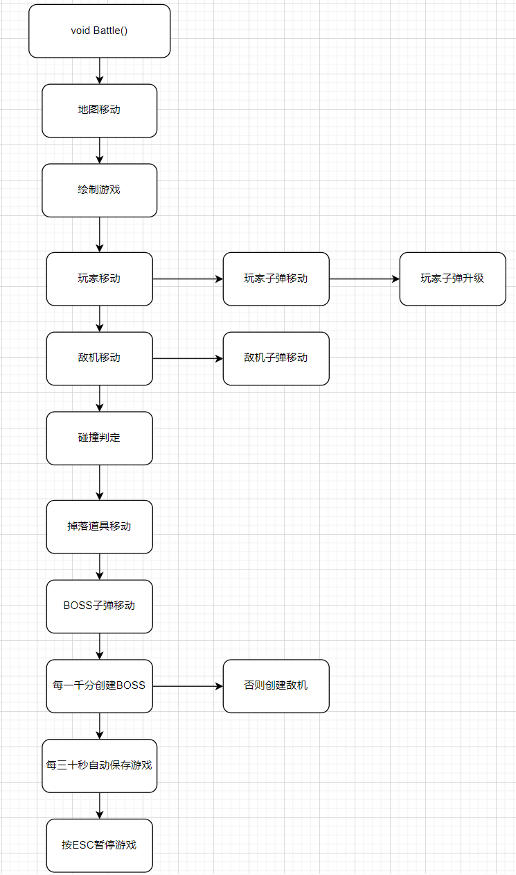

(38)

void GameContinue()

{

map[ifdifficult - 1].width = img_map[ifdifficult - 1].getwidth();

map[ifdifficult - 1].height = img_map[ifdifficult - 1].getheight();

map[ifdifficult - 1].x = 0;

player.width = img_plane[player.type].getwidth();

player.height = img_plane[player.type].getheight();

for (int i = 0; i < SUPPLY_NUM; i++) //初始化补给道具参数

{

supplydrop[i].width = img_supplydrop[i].getwidth();

supplydrop[i].height = img_supplydrop[i].getheight();

}

supply[0].width = img_supply[0].getwidth();

supply[0].height = img_supply[0].getheight();

supply[3].width = img_supply[3].getwidth();

supply[3].height = img_supply[3].getheight();

for (int i = 0; i < PLAYERBULLET_NUM; i++) //初始化玩家子弹参数

{

playerbullet[i].width = img_playerbullet[player.type][player.bulletlevel].getwidth(); //可能有一个问题，之前存档的低级子弹会变高级子弹的参数，小问题先不修

playerbullet[i].height = img_playerbullet[player.type][player.bulletlevel].getheight();

}

for (int i = 0; i < ENEMY_NUM; i++) //初始化敌机参数

{

enemy[i].width = img_enemy[enemy[i].type].getwidth();

enemy[i].height = img_enemy[enemy[i].type].getheight();

}

for (int i = 0; i < ENEMY_NUM; i++) //初始化敌机子弹参数

{

for (int j = 0; j < ENEMYBULLET_NUM; j++)

{

enemybullet[i][j].width = img_enemy[enemy[i].type].getwidth();

enemybullet[i][j].height = img_enemy[enemy[i].type].getheight();

}

}

for (int i = 0; i < BOSS_NUM; i++) //初始化BOSS参数

{

boss[i].width = img_boss[i].getwidth();

boss[i].height = img_boss[i].getheight();

}

for (int i = 0; i < BOSS_NUM; i++) //初始化BOSS子弹参数

{

for (int j = 0; j < BOSSBULLET_NUM; j++)

{

bossbullet[i][j].width = img_bossbullet[i].getwidth();

bossbullet[i][j].height = img_bossbullet[i].getheight();

}

}

for (int i = 0; i < BOSSBOMB_NUM; i++) //初始化BOSS导弹参数

{

bossbomb[i].width = img_bossbomb.getwidth();

bossbomb[i].height = img_bossbomb.getheight();

}

SCENE = BATTLE;

}

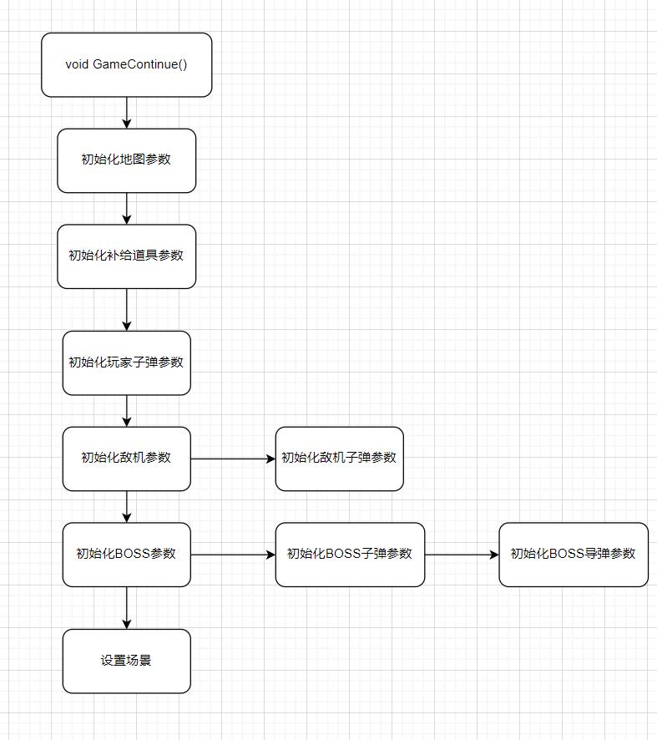

(39)

void ScoreList()

{

FlushBatchDraw();

putimage(0, 0, &img_scorelist);

settextcolor(WHITE);

settextstyle(30, 0, "宋体");

setbkmode(TRANSPARENT);

int recgap = 63; //间距

int recx = 150;

int recy = 190;

for (int i = 0; i < 10; i++)

{

RECT r = { recx, recy, recx + 170, recy + 30 };

drawtext((role[i].name), &r, DT_CENTER | DT_VCENTER | DT_SINGLELINE); //输出昵称

r = { recx + 170, recy, recx + 340, recy + 30 };

char scoresnow[10];

sprintf(scoresnow, "%d", role[i].score); //输出分数

drawtext((scoresnow), &r, DT_CENTER | DT_VCENTER | DT_SINGLELINE);

recy += recgap;

}

for (int i = 0; i < 256; i++)

{

if (GetAsyncKeyState(i) && TimerZero(300, 0, 2)) //按下任意键返回菜单

SCENE = MENU;

}

}

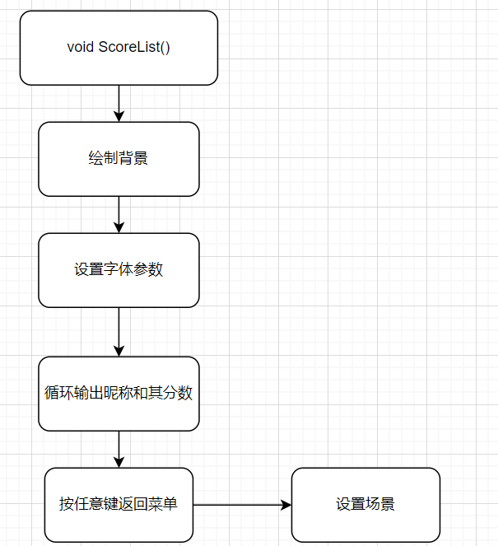

(40)

void About(const char* filename)

{

FlushBatchDraw();

putimage(0, 0, &img_about);

settextcolor(WHITE);

settextstyle(36, 0, "华文新魏");

setbkmode(TRANSPARENT);

int recgap = 63; //间距

int recx = 20;

int recy = 20;

FILE* fp = fopen(filename, "r");

if (!fp)

{

printf("%s open failed:%s\n", filename, strerror(errno));

return;

}

char about[BUFSIZ];

while (!feof(fp)) //读取文件

{

for (int i = 0; i < 10; i++)

{

if (!fgets(about, BUFSIZ, fp))

break;

RECT r = { recx, recy, recx + 467, recy + 30 };

drawtext((about), &r, DT_LEFT | DT_VCENTER | DT_SINGLELINE);

recy += recgap;

}

}

fclose(fp);

for (int i = 0; i < 256; i++)

{

if (GetAsyncKeyState(i) && TimerZero(300, 0, 2)) //按下任意键返回菜单

SCENE = MENU;

}

}

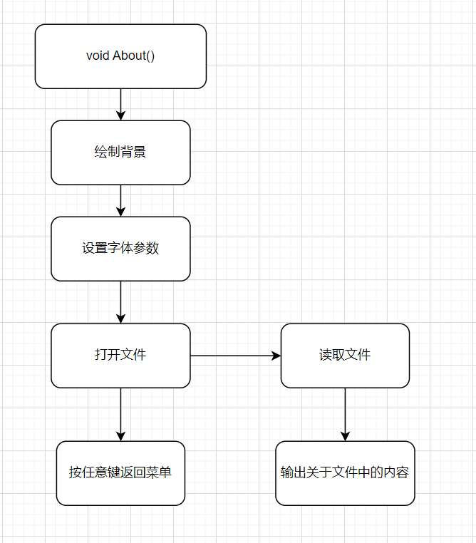

(41)

int main()

{

srand((unsigned)time(NULL)); //时间随机数

HWND hWnd = initgraph(WINDOWWIDTH, WINDOWHEIGHT);

SetWindowPos(GetHWnd(), NULL, 500, 20, 0, 0, SWP_NOSIZE); //创建窗口的位置

LoadImage();

GameInit(); //游戏初始化

strcpy(gamer.name, "0"); //初始化昵称

LoadList("./scorelist.txt"); //读取排行榜

while (1)

{

ExMessage msg;

BeginBatchDraw();

while (SCENE == MENU) //菜单

{

FlushBatchDraw();

peekmessage(&msg, EM_MOUSE);

StartMenu(&msg);

if (GetAsyncKeyState(VK_ESCAPE))

closegraph();

}

while (SCENE == GAMESTART) //游戏开始

{

peekmessage(&msg, EM_MOUSE);

GameStart(&msg);

}

while (SCENE == BATTLE) //开始战斗

{

peekmessage(&msg, EM_MOUSE);

Battle(&msg);

}

while (SCENE == GAMECONTINUE)

{

Load("./data.txt"); //读档

while (SCENE == GAMECONTINUE) //继续游戏

{

GameContinue();

}

}

while (SCENE == GAMEOVER) //游戏结束

{

ExMessage msg;

peekmessage(&msg, EM_MOUSE);

FlushBatchDraw();

GameOver(&msg);

}

while (SCENE == SCORELIST) //排行榜

{

ScoreList();

}

while (SCENE == ABOUT) //排行榜

{

About("./about.txt");

}

while (SCENE == GAMESTOP) //游戏暂停

{

peekmessage(&msg, EM_MOUSE);

GameStop(&msg);

}

EndBatchDraw();

}

return 0;

}

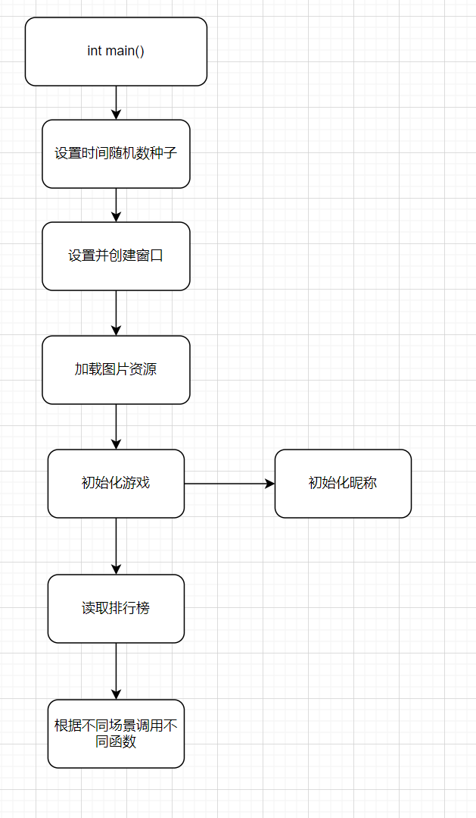

## 测试分析

1. 测试与调试

游戏菜单加载正常，菜单BGM播放正常

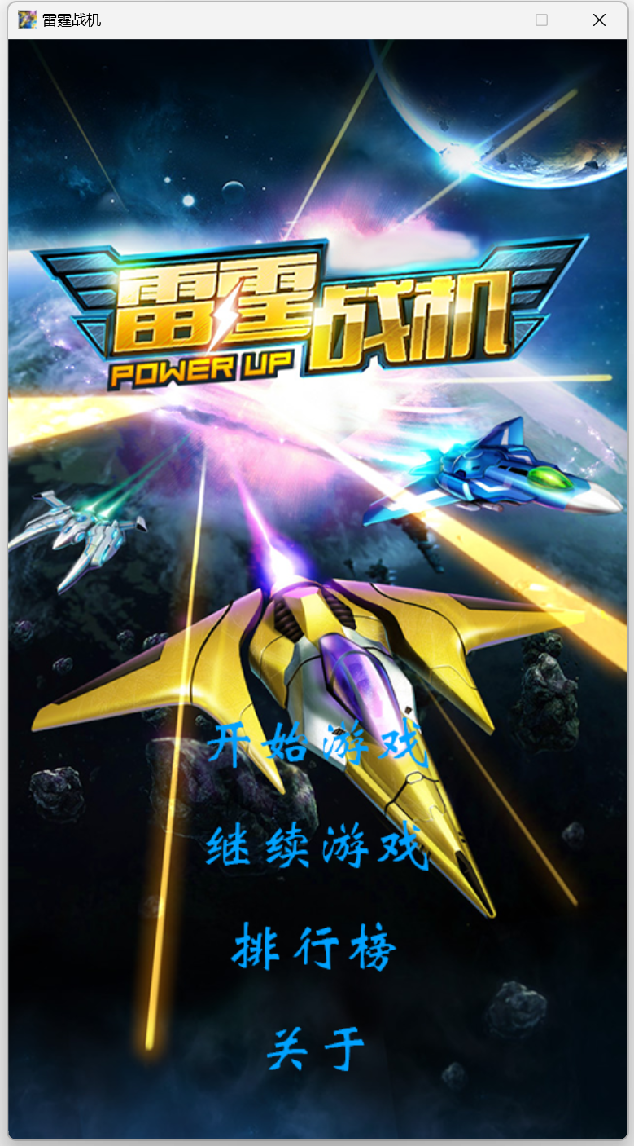

开始游戏，选择飞机正常，选择难度按钮发光正常，子弹演示正常

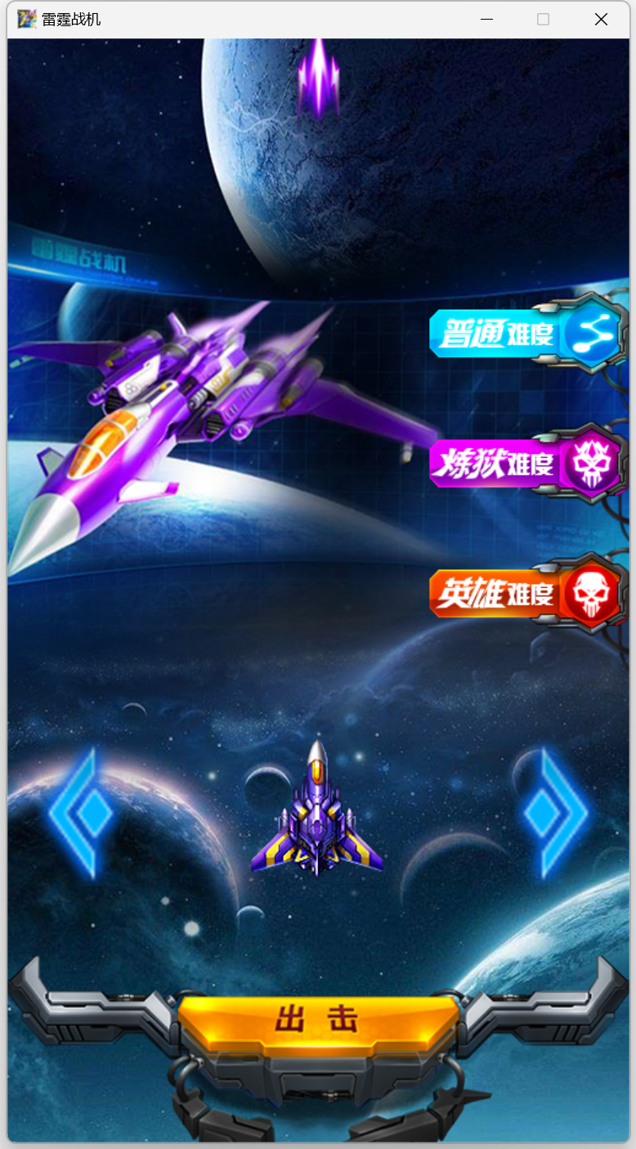

开始游戏攻击判定正常，游戏正常，BGM更换正常，子弹升级正常，道具正常

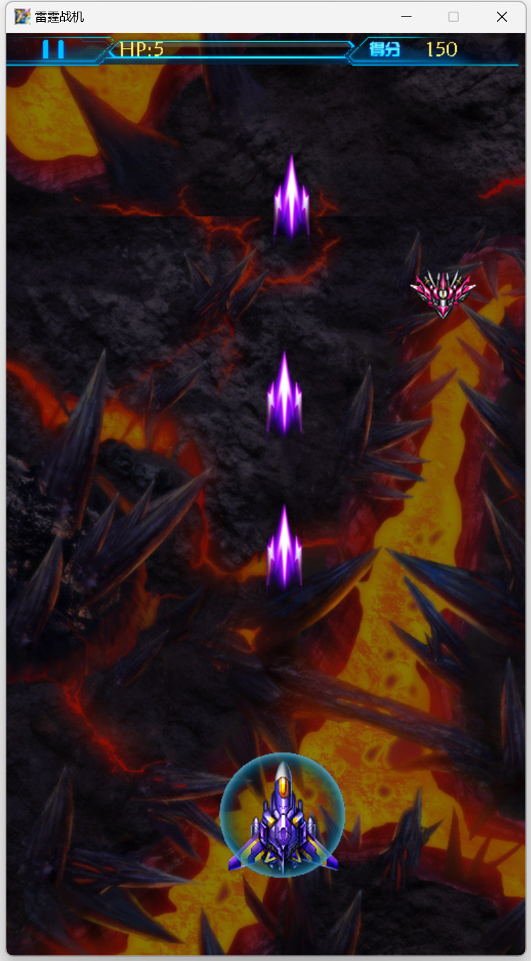

游戏暂停正常，存盘读盘正常

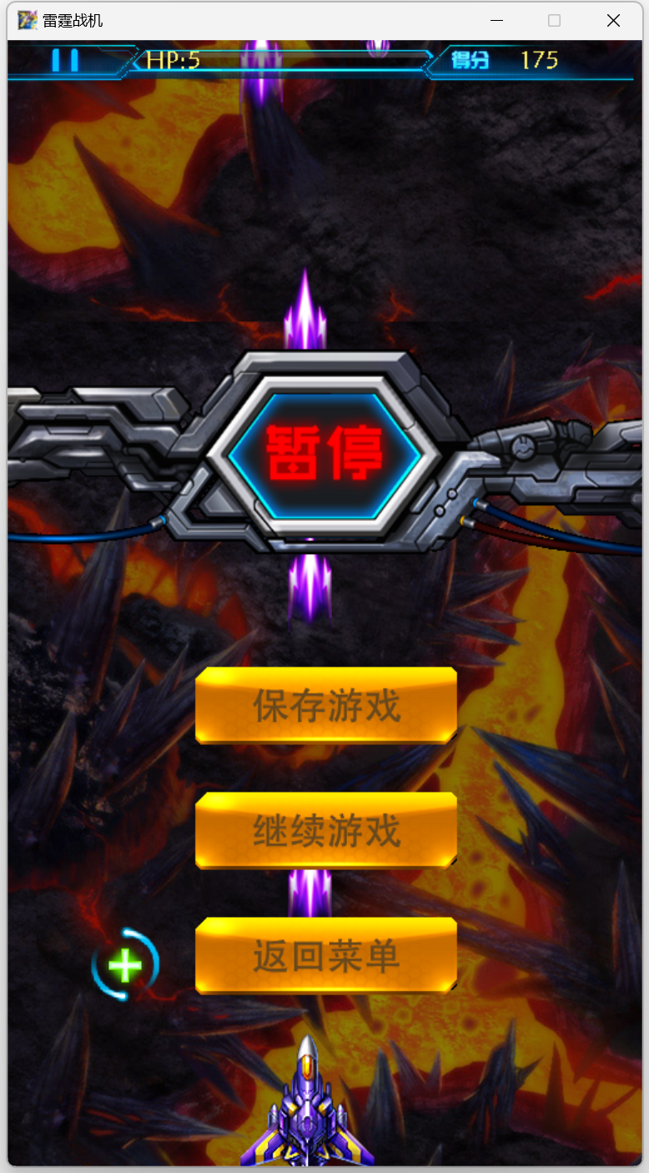

正常结束游戏

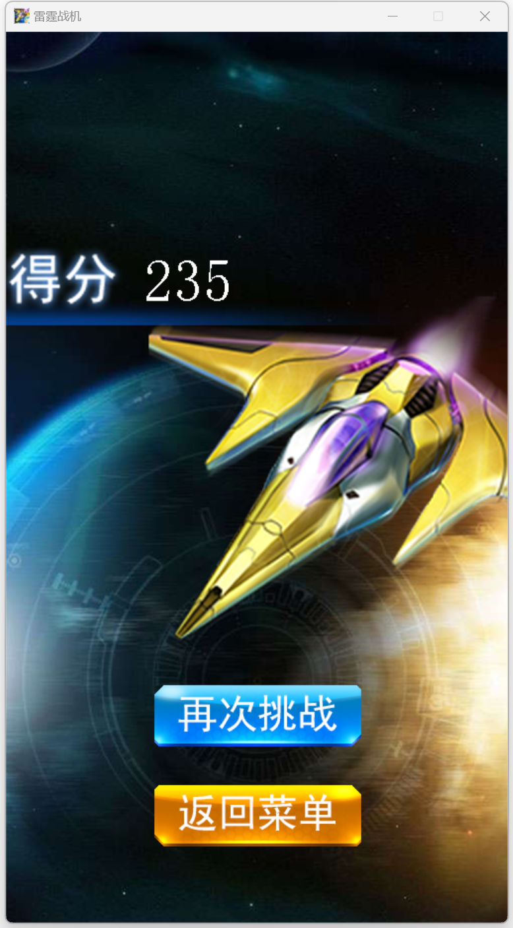

成绩排行榜功能正常

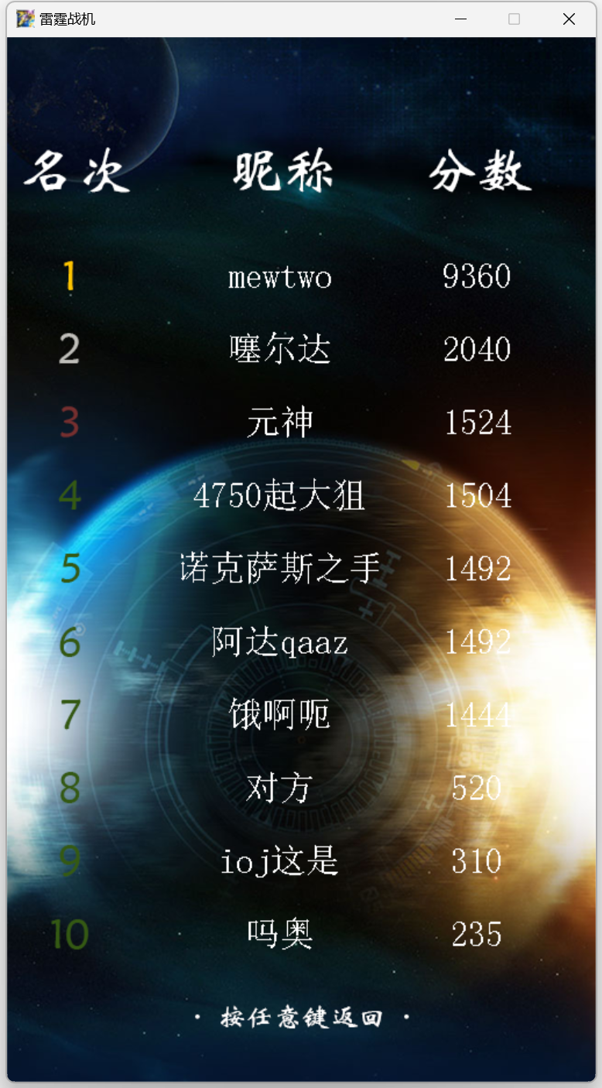

1. 测试结果分析

一切正常，无明显问题。

1. 结论

游戏设计较为成功，可以增加更多玩法，使玩家有不同的游戏体验。还可以优化算法，使游戏更加流畅。

## 系统演示

1. 系统每个功能运行截图与说明

游戏菜单，可以选择开始游戏或者继续上次存盘的游戏



输入昵称

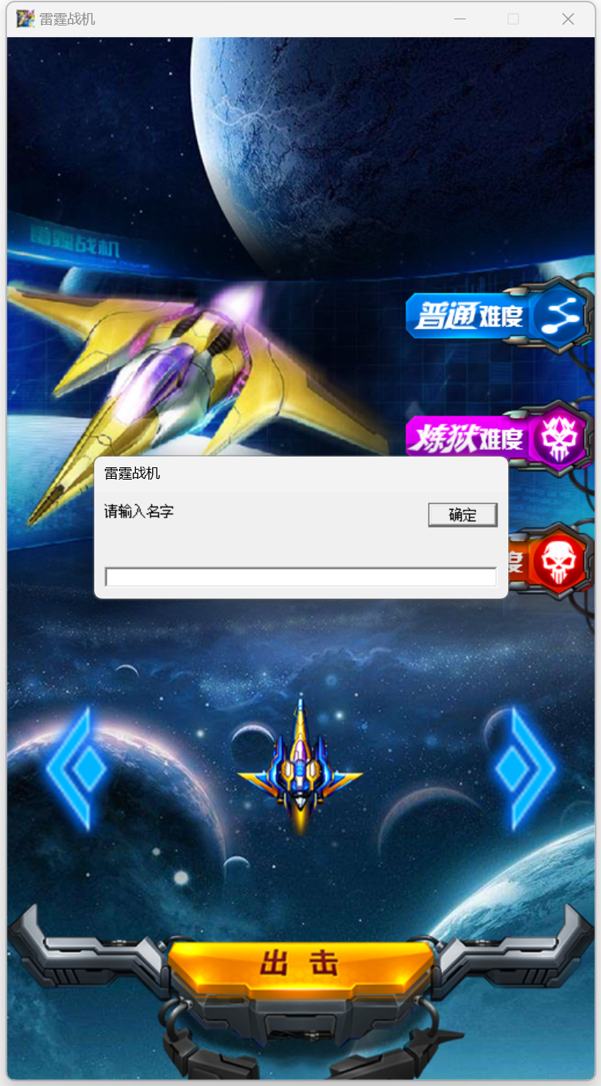

选择飞机及难度，可以选择不同飞机即不同子弹

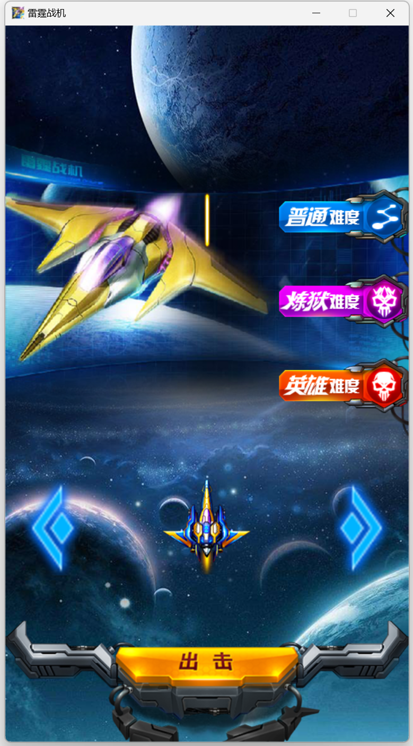

战斗场景，包括地图展示，鼠标控制移动，敌我子弹发射，碰撞检测，子弹威力升级，炸弹功能

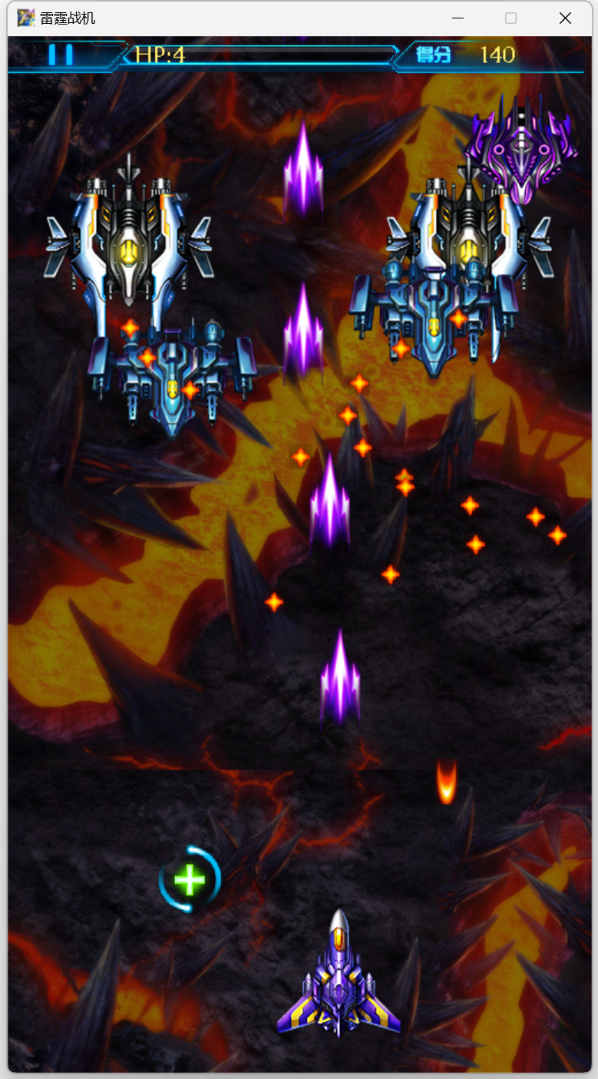

BOSS战

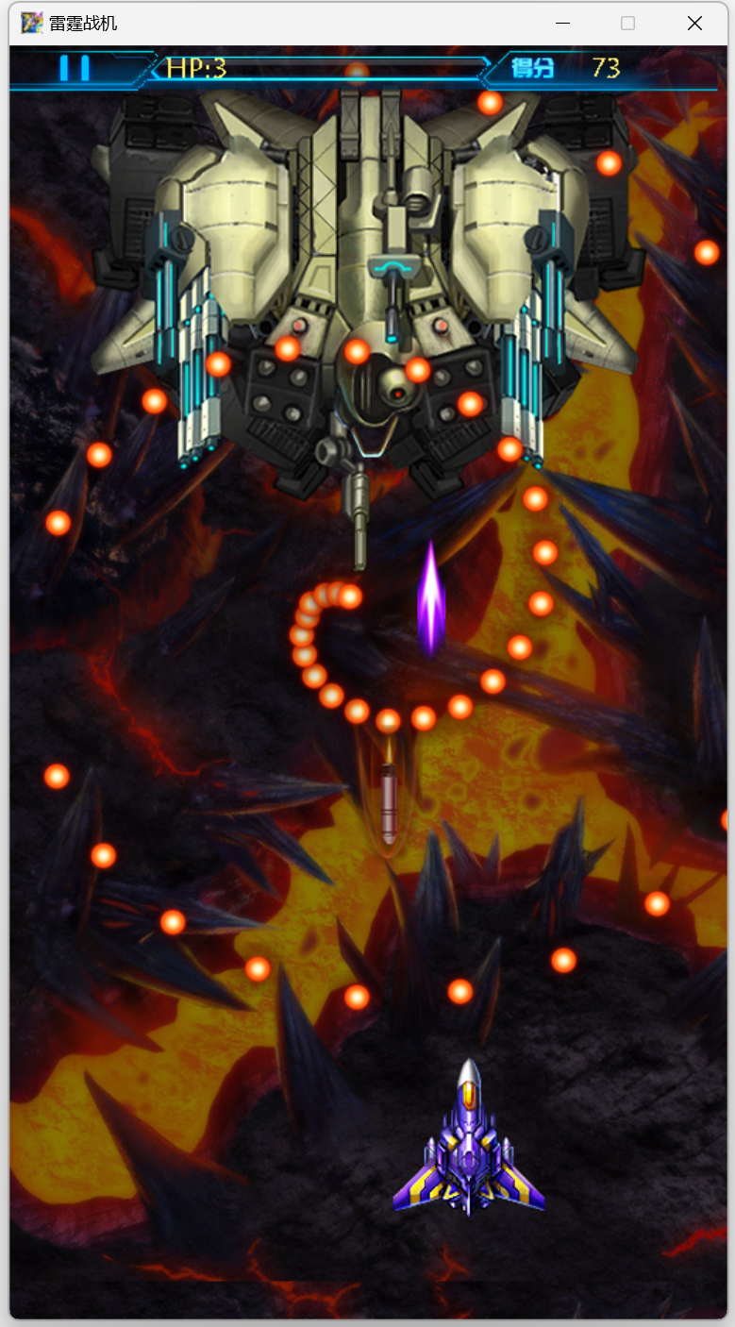

按ESC暂停，支持游戏手动存盘

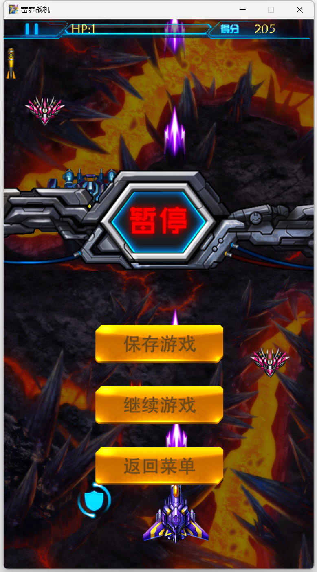

游戏结束

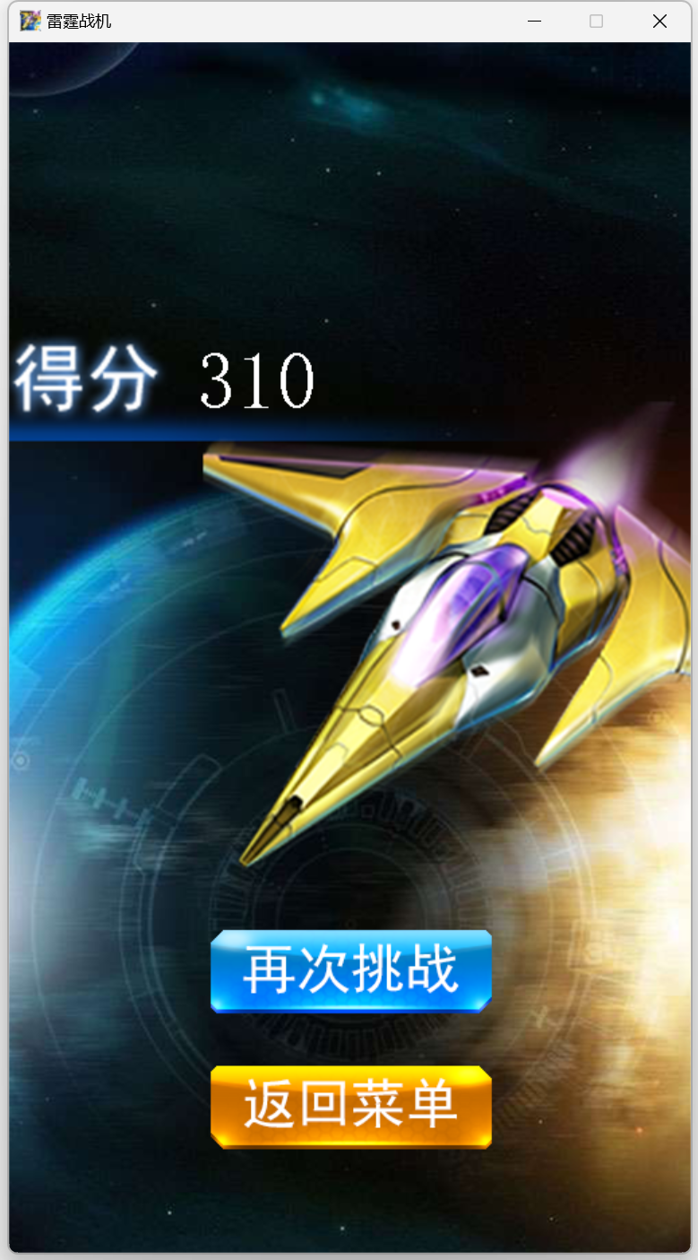

排行榜

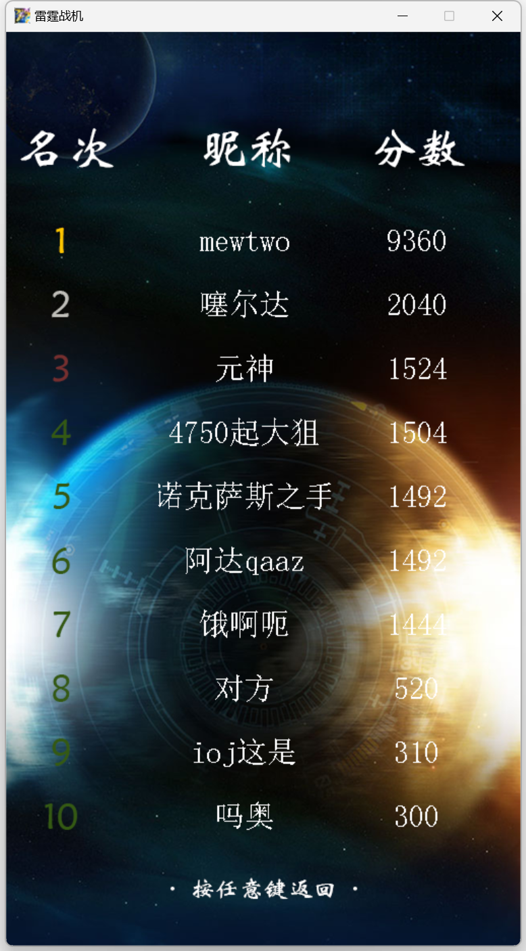

关于

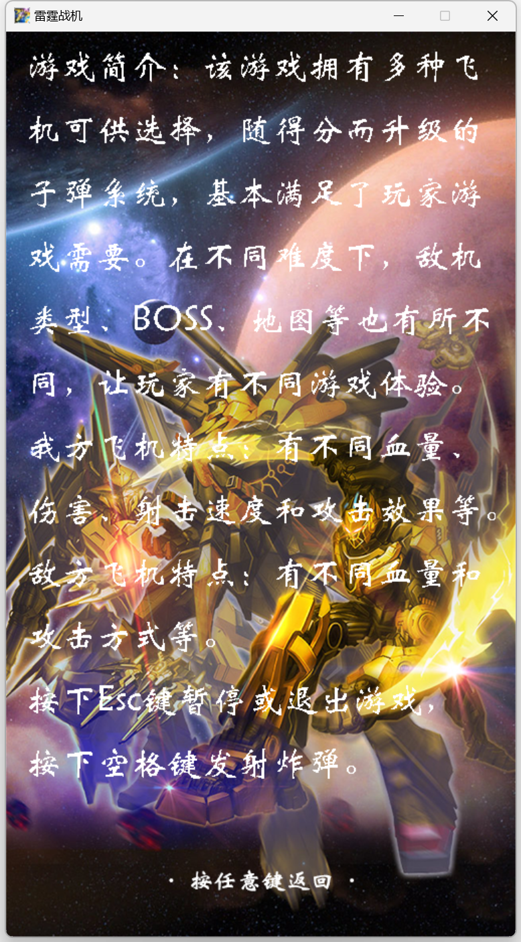

## 设计体会

1. 设计过程中的问题及其解决方案

（1）透明贴图问题。刚开始用的掩码图，每一张素材都需要自己PS掩码图，做起来繁琐且实际使用效果不好。在网上大量搜索资料之后找到一个巧妙的函数，利用贝叶斯定理实现透明贴图，同时也存在计算量过大的问题，于是将二者相结合使用，解决了此问题。

（2）玩家移动卡顿及只能在控制台输入的问题。使用GetAsyncKeyState()非阻塞函数解决了卡顿及只能在控制台输入的问题。后来使用鼠标控制玩家移动，不仅更加解决了这两个问题而且提高了玩家游戏体验。

（3）子弹创建位置每次都要手动设置位置的问题。使用getwidth()函数自动获取图像宽度，再用位置加上二分之一宽度即可。

（4）子弹包括种类、等级和编号三个特征使用二维数组无法解决的问题。图片使用种类和等级两个特征用二维数组解决，子弹使用种类和编号两个特征作为二维数组，等级随玩家升级变化，作为子弹结构体中bulletlevel元素。

（5）玩家无敌时间闪烁问题。该问题的解决需要设置闪烁时长及闪烁状态，解决方案为定义了invincibility[2]数组invincibility[0]控制闪烁时长，invincibility[1]控制闪烁。

（6）播放音乐导致游戏卡顿问题。使用多线程播放短的音效和mciSendString()函数解决了该问题。使用动态数组不断地用系统时间给音乐赋别名也可以解决该问题。

（7）不断要求输入昵称的问题。在游戏打开时候给玩家昵称赋0，再判断玩家名称是否为0以输入昵称解决了该问题。

（8）游戏速度过快的问题。在主要游戏运行函数中加上Sleep()函数解决了该问题。

（9）读档但不能进行游戏初始化导致无游戏元素图片尺寸无法计算的问题。创建一个GameContinue()函数，在继续游戏时调用初始化需要的参数以解决问题。

（10）有的事件需要第一次调用就触发如鼠标点击判定而有的事件不能第一次调用触发且都用的一个定时器的问题。解决方案为设置两个定时器，一个TimerZero()和TimerOne()分别处理这两种情况。

（11）敌机子弹过于密集玩家不便躲避且疏散敌机子弹或者减小玩家贴图都会造成游戏不美观的问题。将玩家判定区域缩小解决了这个问题。

1. 设计过程中的错误及其原因分析

（1）道具掉落在屏幕之外的错误。产生原因是敌机还未完全出现在屏幕中便被击落，而产生的道具位置为敌机位置。加上一个判断敌机是否完全出现在屏幕中，若未完全出现则产生道具的纵坐标为0得以解决该错误。

（2）特殊敌机刷新条件为gamer.score % 100 == 0 导致游戏刚开始就刷新且不断刷新的错误。产生原因是刚开始分数就为0，再补充上gamer.score != 0 && rand() % 2两个条件得以解决改错误。

（3）BOSS子弹三的圆周不匀称的错误。产生原因为创建子弹时，子弹y轴速度成等差数列，但圆周周长却不成等差数列导致。用r * cos(PAI / 2 * k / smallpartnum)等数学公式解决了该错误。

（4）游戏暂停时双方虽然不会动但是子弹还在创建的错误。产生原因是游戏暂停的函数中调用了相关子弹产生函数，删除得以解决错误。

（5）激光战机子弹一碰敌机就死亡的错误。产生原因是激光一直存在，而击中判定是是否有交集，即没有判定CD，导致伤害超标问题，加上判定CD即为激光战机射击速度解决了该错误。

（6）刚刚打完BOSS又产生一个BOSS的错误。产生原因是BOSS创建条件为玩家每获得一千分创建BOSS而击中BOSS也能获得积分，导致刚打完又产生了BOSS。设置一个hitboss结构体，用hitboss.score记录玩家打BOSS的得分，判定产生BOSS时用玩家积分减去打BOSS的积分解决该问题，且hitboss.score需初始化为999，否则一开始就会产生发生BOSS战的错误。

（7）敌机子弹规则突然发生变化的错误。产生原因是敌机一死亡后，产生的敌机二编号为敌机一的编号，敌机一仍存在的子弹就会变为敌机二的子弹规则导致子弹突然发生变化。在创建敌机时加上判定该敌机子弹是否已经全部消失解决了错误。

（8）狂暴或者护盾第二次获得时持续时间为0的错误。产生原因为用的TimerOne()函数判定是否到一定时间使道具效果消失，但是未获得道具时持续时间也会流逝，所以为他们特别使用二维数组中一行作为每次调用，每次调用都会使用新的变量，解决了这个错误。

（9）鼠标只点击了一次，界面跳转好几次的错误。产生原因是鼠标按下有短暂的持续时间，而这个判定没有间隔，错把一次点击判定为好几次，使用TimeZero()函数，为每次鼠标点击判定加上了一个间隔得以解决该错误。

1. 体会和收获

在本次课程设计作业中，我体会到了完成一个游戏制作过程的复杂和困难。从最开始一个空白窗口到后面多彩的界面，我感触颇深，对最后运行的结果比较满意，感觉这一个月以来的努力没有白费。我也在这次制作过程中获得了很多收获。我编程能力获得了极大的提升，制作游戏需要有较强的逻辑思维和动手能力，由于游戏包含内容多，更加综合，需要更加细致和谨慎，同时也需要学习一些新的东西所以我通过制作游戏，锻炼了自己的编程能力，切实地提升我的代码实现能力，此外，制作这样的大程序，代码规范是必不可少的，经过此次游戏设计之后，我的代码也更加整洁规范。而且我还提高了我的创造力，制作游戏需要有独立思考和创新能力，需要去探索新的玩法、新的内容，比如我的雷霆战机地子弹规则，虽然之前的游戏也有过类似的设计，但是没有相关的代码可供参考，我完全通过自己的思考创作出了这些子弹规则，很有成就感。并且我也熟悉游戏开发流程，在制作游戏的过程中，需要遵循一系列的开发流程和规范，比如需求分析、设计、开发、测试等等。我自己一个人亲身经历了这些步骤，体会到了其中的困难与快乐。总之，制作C语言游戏是一个有趣的、具有挑战性和充满收获的过程，可以提高自己的编程能力，同时也可以让自己学习更多新的知识，在收获过程中充实并快乐自我。